Task: Subtask 5.17.1.5 – Data-Driven Fault Detection and Process Control for Potable Reuse with Reverse Osmosis

**PROGRESS AND STATUS BY SUBTASK:**

# **Task: Task 5.17.1** – Desktop Evaluations

### Budget Spent (YCA)

|  |  |  |
| --- | --- | --- |
| **Task** | **Fed Funding** | **Yokogawa In Kind** |
| **1 [Year 1]** | $31,570.00 | $16,450.00 |
| **2 [Year 2]** | $41,460.00 | $16,420.00 |
| **3 [Year 3]** | $12,720.00 | $5,740.00 |

|  |  |  |  |
| --- | --- | --- | --- |
| **Funding Source** | **Organization Spending the Budget** | **Estimated Budget (Total)** | **$ Spent thru reporting quarter (Total)** |
| NAWI (Fed Funds) | YCA | $85,750 | $85,750 |
| YCA (Cost Share) | YCA | $38,610 | $36,294 |

## **Task:** **Subtask 5.17.1.5 –** Data-Driven Model Optimization (DDMO) for Chloramine and Anti-Scalant Dosing

**Subtask Lead: Steve Hayden**

Research Questions:

* How much cost and energy could be saved across the reuse treatment train applying DDMO to adjust the pre-chloramine and antiscalant doses and predict a fault in real-time in response to water quality changes?

**PROGRESS AND STATUS:**

* Collected data from:
  + Orange County Water District
    - All necessary data is available and shared among the team
  + Las Virgenes Municipal Water District
    - All necessary data is available and shared among the team
  + West Basin Municipal Water District
    - Additional data from WBMWD is still needed.

### Budget Spent (YCA)

### Summary

In Orange County Water District, data analysis aims to create a model for RO membrane operation optimization in terms of preventing mineral scaling and saving acid and anti-scalant consumptions. To achieve this objective, we adopted the analytical approach combining the statistical model to predict water quality from RO permeate with the physical model based on physicochemical parameters related to flow rate, pressure and water quality measured, and subsequently, to investigate an anti-scalant demand. The scaling potential was estimated from real time mineral monitoring with XACT920 data and saturation index considering concentration polarization at third stage of RO membrane. The statistical model was integrated into the optimization model as a first step. However, anti-scalant dosage could not be reduced by the optimization calculation. The physical model of the concentration polarization on RO membrane surface was considered to create more accurate models than the statistical model. The scaling status of Silica and Calcium can be simulated, and the model decides the necessity and intensity of anti-scalant dosing rate.

In Las Virgenes Municipal Water District, data analysis aims to optimize the total chlorine for stable operation in terms of water quality, flow rate, and pressure. To achieve this objective, we analyzed the effects of input variables on the water quality, created a water quality prediction model, and calculated the optimum total chlorine keeping the predicted water quality within constraints. However, the total chlorine was not reduced by the optimization calculation, which suggests several possibilities: necessity of long-term fouling model, possibility of scaling in addition to fouling, and so on. The currently available data is not enough to draw definitive conclusions, so we would like to recommend performing experiments to identify the relationship between the amount of total chlorine and the progress of clogging.

In West Basin Municipal Water District, we created an hourly average model and a daily average model using the data provided. The model derived the optimum chemical dosage such as ferric chloride dosage that should maintain effluent turbidity from the Title 22 filter less than 2 NTU required by the Title 22 regulations. As a result of the optimization calculation, ferric chloride dosage and cationic polymer dosages were reduced by 7% and 2%, respectively, The Title 22 filter effluent turbidity raised by 4% can be attributed by reduction of the total amount of chemical dosage. However, because the feed and effluent turbidites were measured by only grabbing, the model accuracy was low. We highly recommend installing turbidity instruments online and measured at more frequent and real time that makes it possible to reduce those chemicals based on the fluctuation.

# Desktop Analysis based on OCWD

* 1. **RO Optimization Overview**

Basic optimization story is to decrease the chemical dosing cost (e.g., sulfuric acid or inhibitor) while satisfying water quality standards and preventing progress of RO membrane scaling.

RO optimization is to improve the operation in some period. This type of optimization problem is called a scheduling problem, which is formulated and solved according to procedure as shown in Figure 1.1.1. The procedure consists of drawing flow chart, formulation optimization problem, and calculation operational schedule. In this process, the first and the second are the steps to construct an optimization model and the third is the step to solve an optimization problem using the created model.

* + 1. **Flow Chart**

Figure 1.1.2 shows an example of the flow chart for RO optimization in OCWD. To consider water quality standards and preventing progress of RO membrane scaling, water quality prediction and RO membrane models are introduced as constraints. Chemical dosing costs and constraints are calculated from RO feed variables, i.e., sulfuric acid dosing, temperature, feed conductivity, and feed TOC. This report uses only the water quality prediction model because the RO scaling model is under development and needs more validation in some periods and conditions.

Figure 1.1.3 shows the overall flow chart for RO system configuration in this case. Figure 1.1.3 (a) is the flow chart limited to the part related to permeate TOC prediction and Figure 1.1.3 (b) is the flow chart limited to the part related to permeate EC prediction. In Figure 1.1.3, arrows connecting objects are assigned variables. The classification of each variable (e.g., optimization variable or fixed variable) is described below. A cylindrical object means an exogenous variable, a hexagon object means a mathematical model, and a square object means a predictive variable (e.g., water quality data). An arrow toward an object is an input data and an arrow out from an object is an output data. The color of arrows is different for each object to which it is connected. Mathematical models have both input and output data. Output data from a hexagon object toward a square object is calculated by the prediction model described in the later sections.

The RO system configuration and tag name list of OCWD is provided as “Additional Materials A1” at the appendix of this report.



**Figure 1.1.1: Procedure for Solving Scheduling Problem**

* + 1. **Formulation Optimization Problem**

The optimization problem is formulated as minimizing objective function satisfying constraints. In the optimization problem, $x$ denotes the optimization variable and $f$ denotes the objective function (cost function). A detail of the problem is provided in the next section.

Table 1.1.1 shows the optimization variable list in the OCWD optimization model. An “Optimization Variable” means a cost or manipulated variable (chemical dose), A “Fixed Parameter” is given by actual value, An “Intermediate Variable” indirectly affects the objective function or constraints in the calculation. In OCWD optimization model, the optimization variable is sulfuric acid and threshold inhibitor (e.g., anti-scalant) usage, and the intermediate variables are the permeate electric conductivity (EC) at stage 1, stage 2, and stage 3, combined permeate EC, and combined permeate TOC calculated by water quality prediction model.



**Figure 1.1.2: Flow Chart Example for RO Optimization Calculation in OCWD**



1. **RO Total Flow Chart (Permeate TOC)**



1. **RO Each Stage Flow Chart (Permeate EC)**

**Figure 1.1.3: Flow Chart for RO Optimization Calculation (OCWD)**

**Table 1.1.1: Optimization Variable List (OCWD)**

|  |  |  |  |
| --- | --- | --- | --- |
| ID No. | Description | Unit | Opt. Variable / Fixed Parameter |
| ID0000 | Sulfuric Acid Usage | ton/hour | Optimization Variable |
| ID0001 | Threshold Inhibitor Usage | ton/hour | Optimization Variable |
| ID0002 | Feed EC | $$μS/cm$$ | Fixed Parameter |
| ID0003 | Feed TOC | ppm | Fixed Parameter |
| ID0004 | Feed Temperature | $$℉$$ | Fixed Parameter |
| ID0005 | Feed pH | - | Fixed Parameter |
| ID0100 | Stage 1 Feed Pressure | psi | Fixed Parameter |
| ID0101 | Stage 1 Feed Flow Rate | gpm | Fixed Parameter |
| ID0102 | Stage 1 Permeate Flow Rate | gpm | Fixed Parameter |
| ID0200 | Stage 2 Feed Pressure | psi | Fixed Parameter |
| ID0201 | Stage 2 Feed Flow Rate | gpm | Fixed Parameter |
| ID0202 | Stage 2 Permeate Flow Rate | gpm | Fixed Parameter |
| ID0300 | Stage 3 Feed Flow Rate | gpm | Fixed Parameter |
| ID0301 | Stage 3 Permeate Flow Rate | gpm | Fixed Parameter |
| ID1000 | Stage 1 Permeate EC | $$μS/cm$$ | Intermediate Variable |
| ID2000 | Stage 2 Feed EC |  | Intermediate Variable |
| ID2001 | Stage 2 Permeate EC |  | Intermediate Variable |
| ID3000 | Stage 3 Feed EC |  | Intermediate Variable |
| ID3001 | Stage 3 Permeate EC | $$μS/cm$$ | Intermediate Variable |
| ID4000 | Combined Permeate EC | $$μS/cm$$ | Intermediate Variable |
| ID4001 | Combined Permeate TOC | ppm | Intermediate Variable |

* 1. **Water Quality Prediction**

The water quality models are used as constraints in the overall optimization of RO operation. The chemical dosage is minimized under the condition that the water quality estimated by the model satisfies the water quality standard values. In this chapter we constructed water quality prediction models and validated the accuracy of the created models.

* + 1. **Outliers Removal**

The raw data contains a lot of outliers such as noise and missing values, which have undesirable effects on statistical models. Therefore, outlier removal was performed first.

Constructing different outlier criteria for all variables is unrealistic, so we have established a uniform outlier removal procedure which consists of two steps. The values removed with this procedure were interpolated with the previous values.

Step 1 performs data cleaning with 3 rules.

* Detect the periods where the feed flow rate is below a predefined level.
* Detect the periods where each measured value does not change for a predefined time.
* Detect the moments where the change rate of each variable in one step exceeds a predefined level.

The results are merged, and margins of a predefined timesteps before and after the detected periods are also treated as outliers.

In step 2, outliers are removed using filtering techniques that are common in the field of data analysis, for example, removing values outside of the mean ±3σ of the data and applying a Kalman filter[1]. If all period of a variable is removed by step 1 (i.e., the variable consists only long-term constant periods), we do not apply outlier removal and used raw data.

For the data in OCWD, step 2 was not applied because outliers are removed enough by only step 1. The predefined parameters for step 1 can be found in “Additional Materials A3” at the appendix of this report.

Figure 1.2.1 (a)-(d) show the raw and preprocessed trends of the feed pressure and the 1st stage permeate conductivity from November 2021 to December 2022. We can see that all spiky outliers were removed and the essential behavior of the data is extracted.

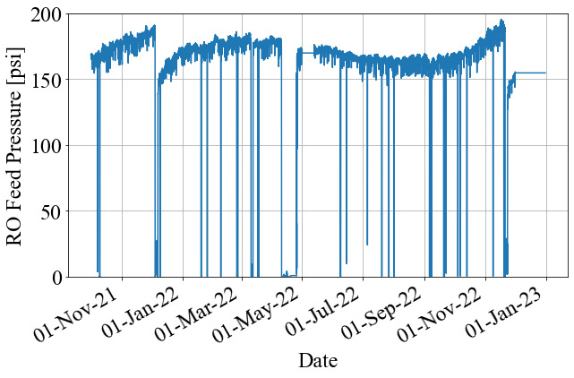 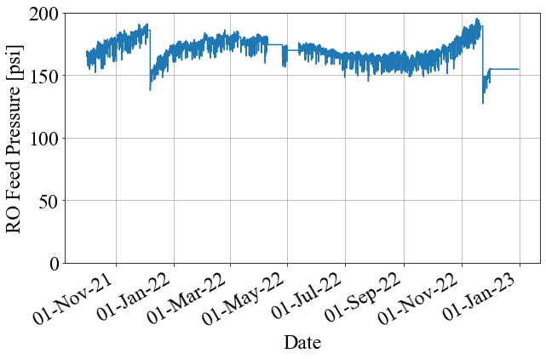

**(a) Raw Feed Pressure (b) Feed Pressure**

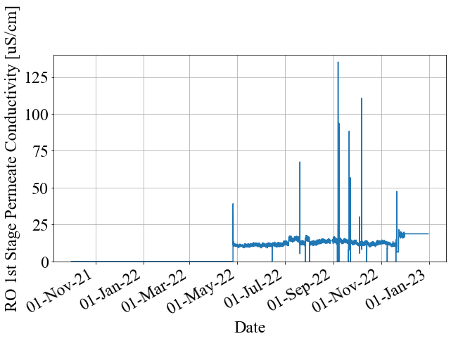 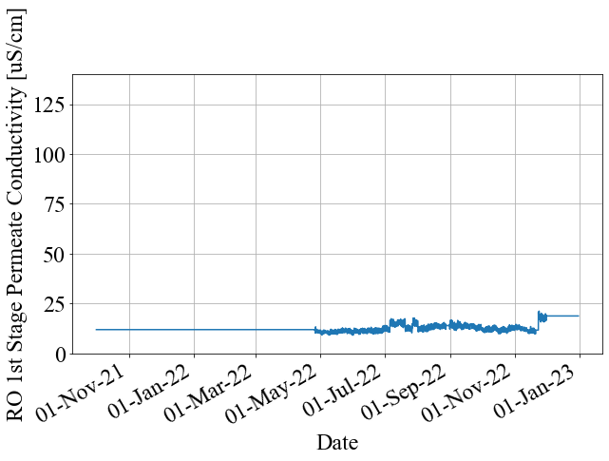

**(c) Raw 1st Stage Permeate Conductivity (d) 1st Stage Permeate Conductivity**

**Figure 1.2.1: Raw and Preprocessed Data (OCWD)**

* + 1. **Prediction Method**

Two methods, the multiple linear regression (MLR) and the random forest (RF), were evaluated for prediction accuracy of the permeate electric conductivity (EC) and permeate TOC. MLR is a linear statistical method and its model is given as follows:

$$\begin{aligned}y=w_{1}x_{1}+w_{2}x_{2}+…+w_{M}x_{M}+w_{0}\#\left(1.2.1\right)\end{aligned}$$

$x_{j}$ ($j=1,2,…,M$) denotes explanatory variable, $y$ denotes predicted variable, $w_{j}$ ($j=1,2,…,M$) denotes coefficient parameter, and $w_{0}$ denotes bias parameter. The parameters $w_{j}$ and the standardized coefficients are estimated by actual data in the training period. The standardized coefficients can be interpreted as relative contribution of each variable $x_{j}$ for prediction of $y$. The detail of the estimation of the parameters is provided as “Additional Materials A4” at the appendix of this report.

Random Forest (RF) is one of the methods based on decision trees. In general, the prediction by RF is given as follows:

$$\begin{aligned}y=\frac{1}{B}\sum_{b=1}^{B}{T_{b}\left(x\right)}\#\left(1.2.2\right)\end{aligned}$$

$B$ is the number of decision trees prepared at training time and $T_{b}$ represents the decision tree. In $T_{b}\left(x\right)$, the if -then rules are applied to the value of $x$, so it is a nonlinear function. Details of the RF formula is provided in Breiman (2001)[2]. Random forest is a black box model based on decision trees and ensemble learning, and it is generally known as a highly accurate and versatile analysis method. MLR can only represent linear models, and RF can represent nonlinearity. RF is expected to have better prediction accuracy due to nonlinear relationships that cannot be expressed by MLR.

We received data measured at 30-minute intervals in RO B01 unit from OCWD. The RO system configuration of OCWD is provided in “Additional Materials A1” at the appendix of this report.

Permeate EC and permeate TOC are considered as indicators of RO membrane scaling and have water quality standards to be satisfied. Permeate EC is measured at each stage of permeate in the B01 unit and the permeate TOC is measured after the permeate flows from the three stages of the whole RO are merged. Therefore, we constructed four models for permeate ECs at 1st, 2nd, and 3rd stages, and permeate TOC at the whole RO. Table 1.2.1 shows the variable list for each water quality prediction model. “X” means an explanatory variable, “Y” means a predicted variable, and “*” means a calculated variable. Tag name list is provided in “Additional Materials A1” at the appendix of this report. Details of calculated variable can be found in “Additional Materials A4” at the appendix of this report.

We used continuous data from May 13th, 2022 to November 18th, 2022 and the other period is excluded because it contains uncontinous data or was under significantly different plant operation conditions. The set of training and evaluation periods slides forward sequentially. Figure 1.2.2 shows overview of sequential prediction. For example, we trained a model with data from May 13th to May 19th, 2022 (1st week) and tested it against data from May 20th to May 27th, 2022 (2nd week) in the first term. In the next term, we slide these periods to 1 week later and conduct re-training (model re-tuning).

The evaluation indexes are Mean Absolute Percentage Error (MAPE) $E_{MAPE}$ [%] and Root Mean Percentage Error (RMSE) $E_{RMSE}$. MAPE indicates a relative prediction error and RMSE is an absolute prediction error. They are calculated between actual data and predicted data in the prediction period. Their mathematical definition is provided in “Additional Materials A4” at the appendix of this report.

**Table 1.2.1: Variable List in Water Quality Prediction Model (OCWD)**

|  |  |  |  |  |
| --- | --- | --- | --- | --- |
| Variable Name | Stage1 Permeate EC | Stage2 Permeate EC | Stage3 Permeate EC | Permeate TOC |
| RO B01 Feed Pressure | X |  |  | X |
| RO Feed EC | X |  |  | X |
| RO Feed Flow Rate * | X |  |  | X |
| RO Feed Temperature | X | X | X | X |
| RO Feed pH | X |  |  | X |
| Sulfuric Acid Usage | X | X | X | X |
| Threshold Inhibitor Usage | X | X | X | X |
| RO B01 Stage 2 Feed Pressure |  | X |  | X |
| RO B01 Stage 2 Feed EC * |  | X |  |  |
| RO B01 Stage 2 Feed Flow Rate * |  | X |  |  |
| RO B01 Stage 3 Feed EC * |  |  | X |  |
| RO B01 Stage 3 Feed Flow Rate * |  |  | X |  |
| RO Feed TOC |  |  |  | X |
| RO B01 Stage 1 Permeate EC | Y |  |  |  |
| RO B01 Stage 2 Permeate EC |  | Y |  |  |
| RO B01 Stage 3 Permeate EC |  |  | Y |  |
| RO Permeate TOC |  |  |  | Y |

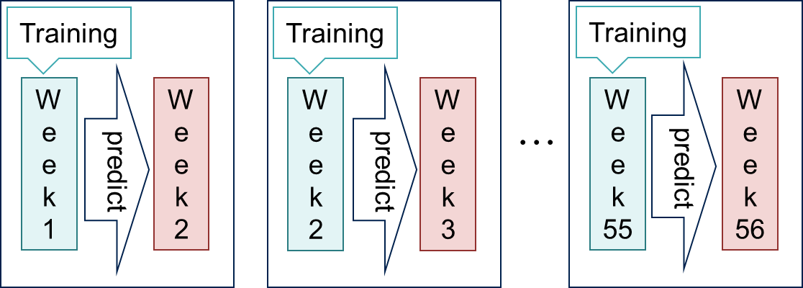

**Figure 1.2.2: Overview of Sequential Prediction (OCWD)**

* + 1. **Prediction Results**

Table 1.2.2 shows prediction accuracy result by MLR. The trends of the prediction results are shown in Figure 1.2.3 (a)-(d). In Figure 1.2.3, blue lines indicate preprocessed actual data and orange lines indicate predicted data. Table 1.2.3 shows prediction accuracy result by RF. The trends of the prediction results are shown in Figure 1.2.4 (a)-(d). In Figure 1.2.4, blue lines indicate preprocessed actual data and orange lines indicate predicted data.

RF predict water qualities better than MLR. Figure 1.2.5 re-posts the predicted trends of 3rd Stage Permeate Conductivity by MLR and RF. This Figure shows that the values by MLR during the periods marked with dashed red circles were predicted far off from preprocessed actual data comparing to the prediction during corresponding period by RF. This difference is considered to come from the effect of extrapolation. RF only predicts within the range of variables observed during training period. On the other hand, MLR can output predicted values beyond the range of value observed during training period.

**Table 1.2.3: Prediction Accuracy Result by Random Forest (OCWD)**

|  |  |  |  |  |
| --- | --- | --- | --- | --- |
| **Index** | **Stage1**  **Permeate EC** | **Stage2**  **Permeate EC** | **Stage3**  **Permeate EC** | **Permeate TOC** |
| **RMSE** | 1.10 [uS/cm] | 2.48 [uS/cm] | 8.15 [uS/cm] | 0.0099 [ppm] |
| **MAPE** | 6.25 [%] | 7.23 [%] | 9.62 [%] | 11.10 [%] |

**Table 1.2.2: Prediction Accuracy Result by MLR (OCWD)**

|  |  |  |  |  |
| --- | --- | --- | --- | --- |
| **Index** | **Stage1**  **Permeate EC** | **Stage2**  **Permeate EC** | **Stage3**  **Permeate EC** | **Permeate TOC** |
| **RMSE** | 2.94 [uS/cm] | 3.92 [uS/cm] | 14.70 [uS/cm] | 0.014 [ppm] |
| **MAPE** | 9.28 [%] | 10.48 [%] | 15.47 [%] | 13.60 [%] |

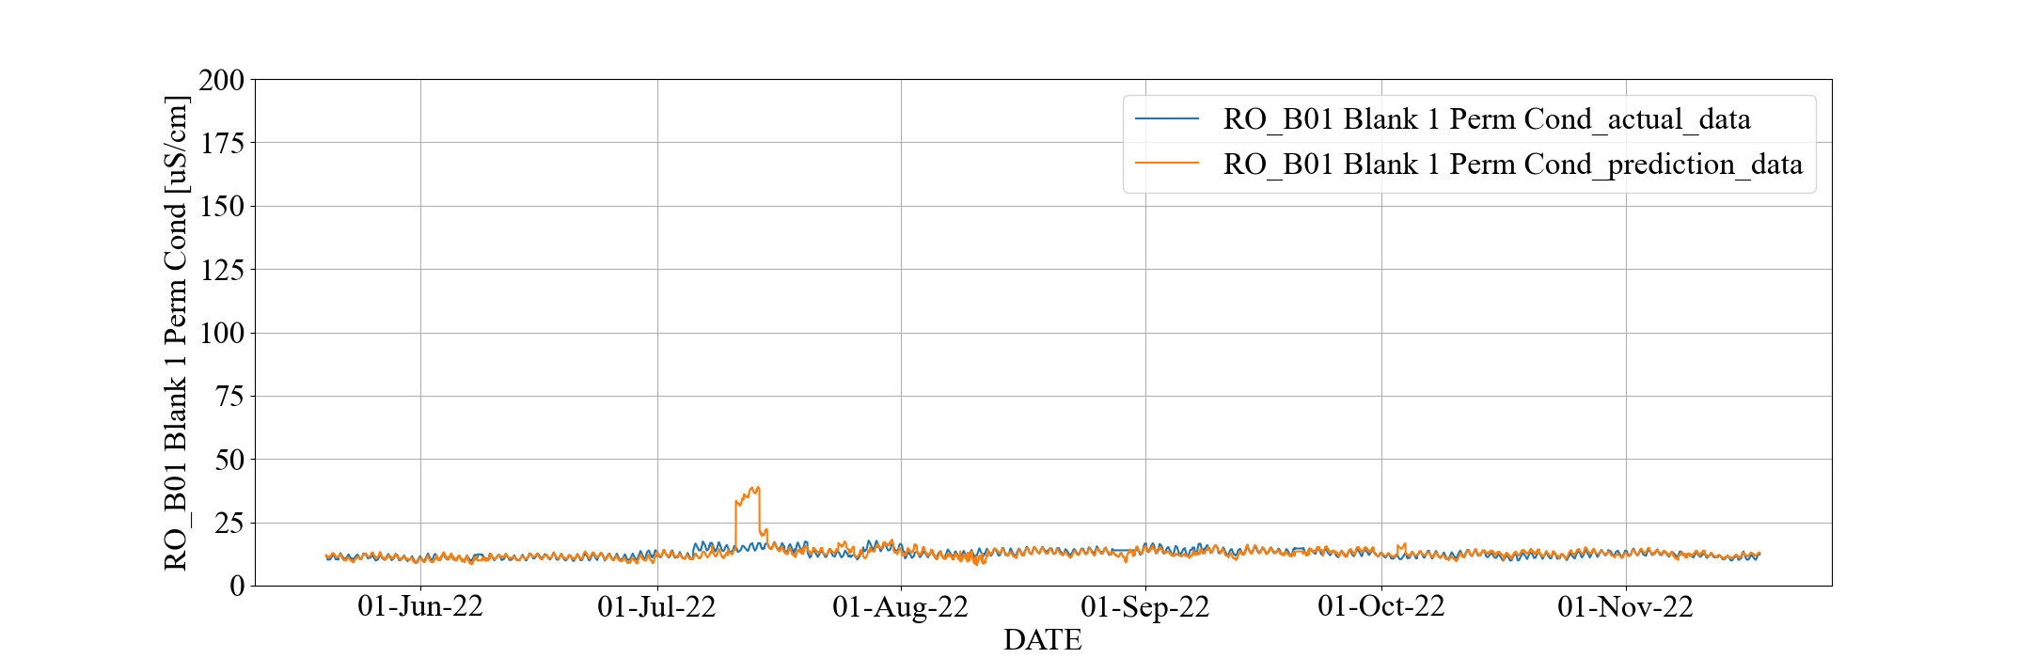

**(a) 1st Stage Permeate Conductivity**

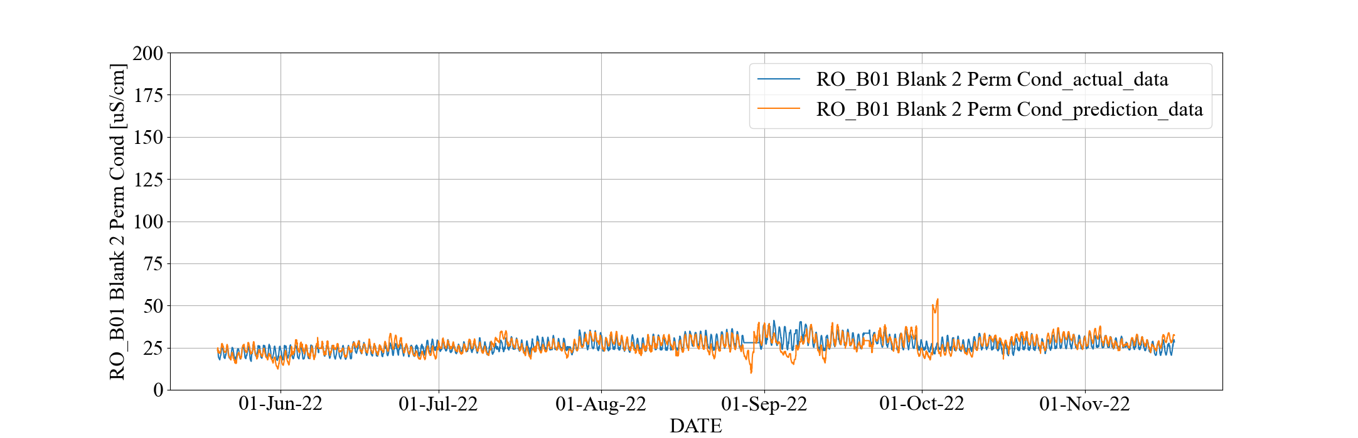

**(b) 2nd Stage Permeate Conductivity**

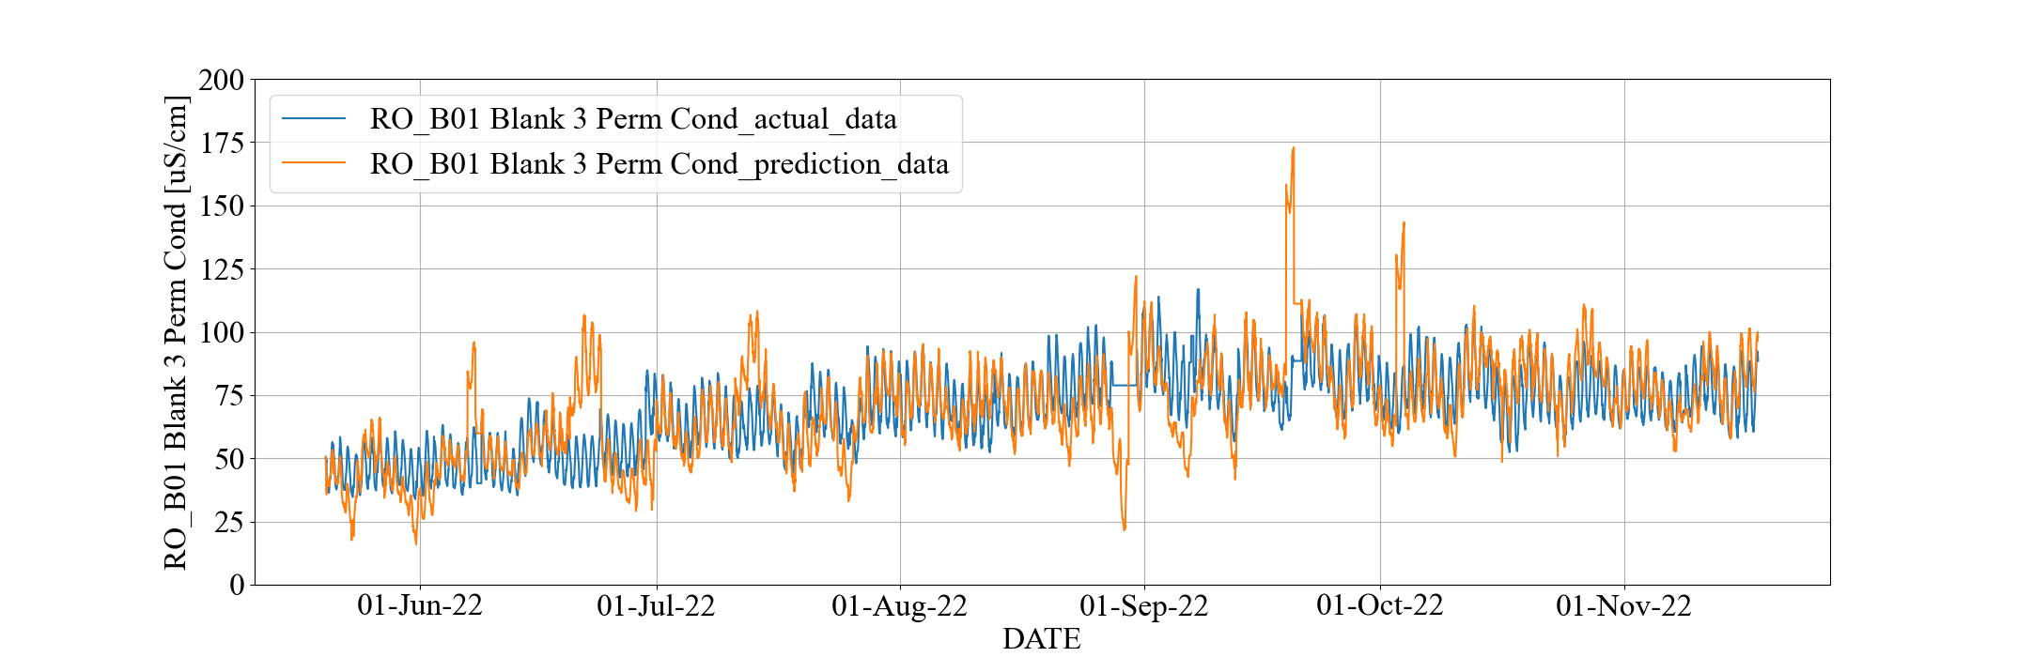

**(c) 3rd Stage Permeate Conductivity**

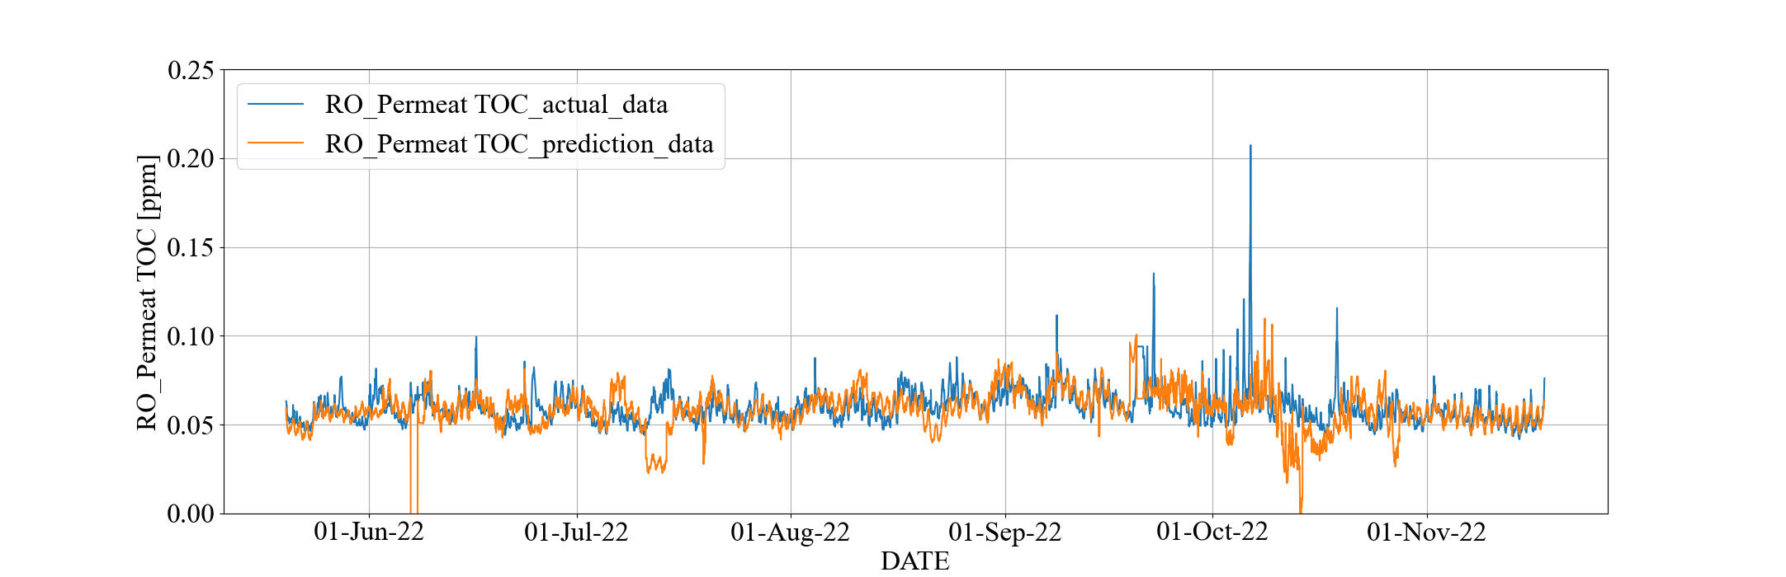

**(d) Permeate TOC**

**Figure 1.2.3: Prediction Trend in All Period with MLR (OCWD)**

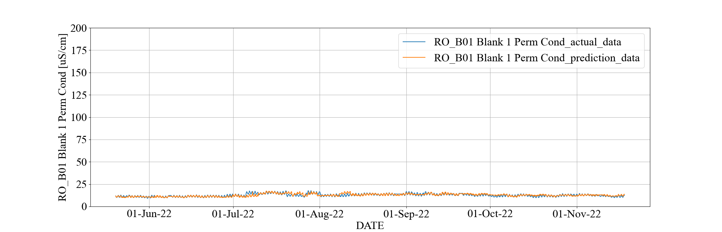

**(a) 1st Stage Permeate Conductivity**

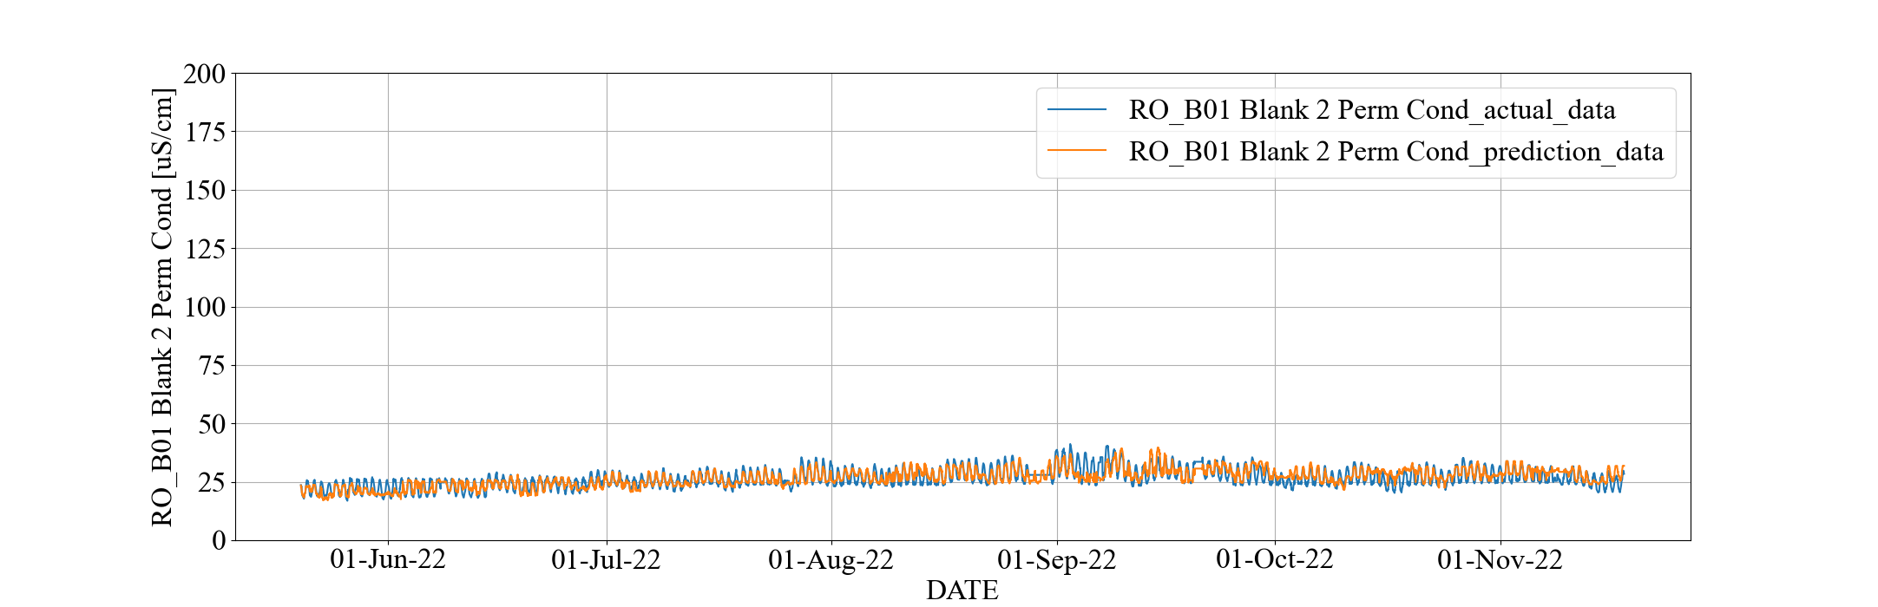

**(b) 2nd Stage Permeate Conductivity**

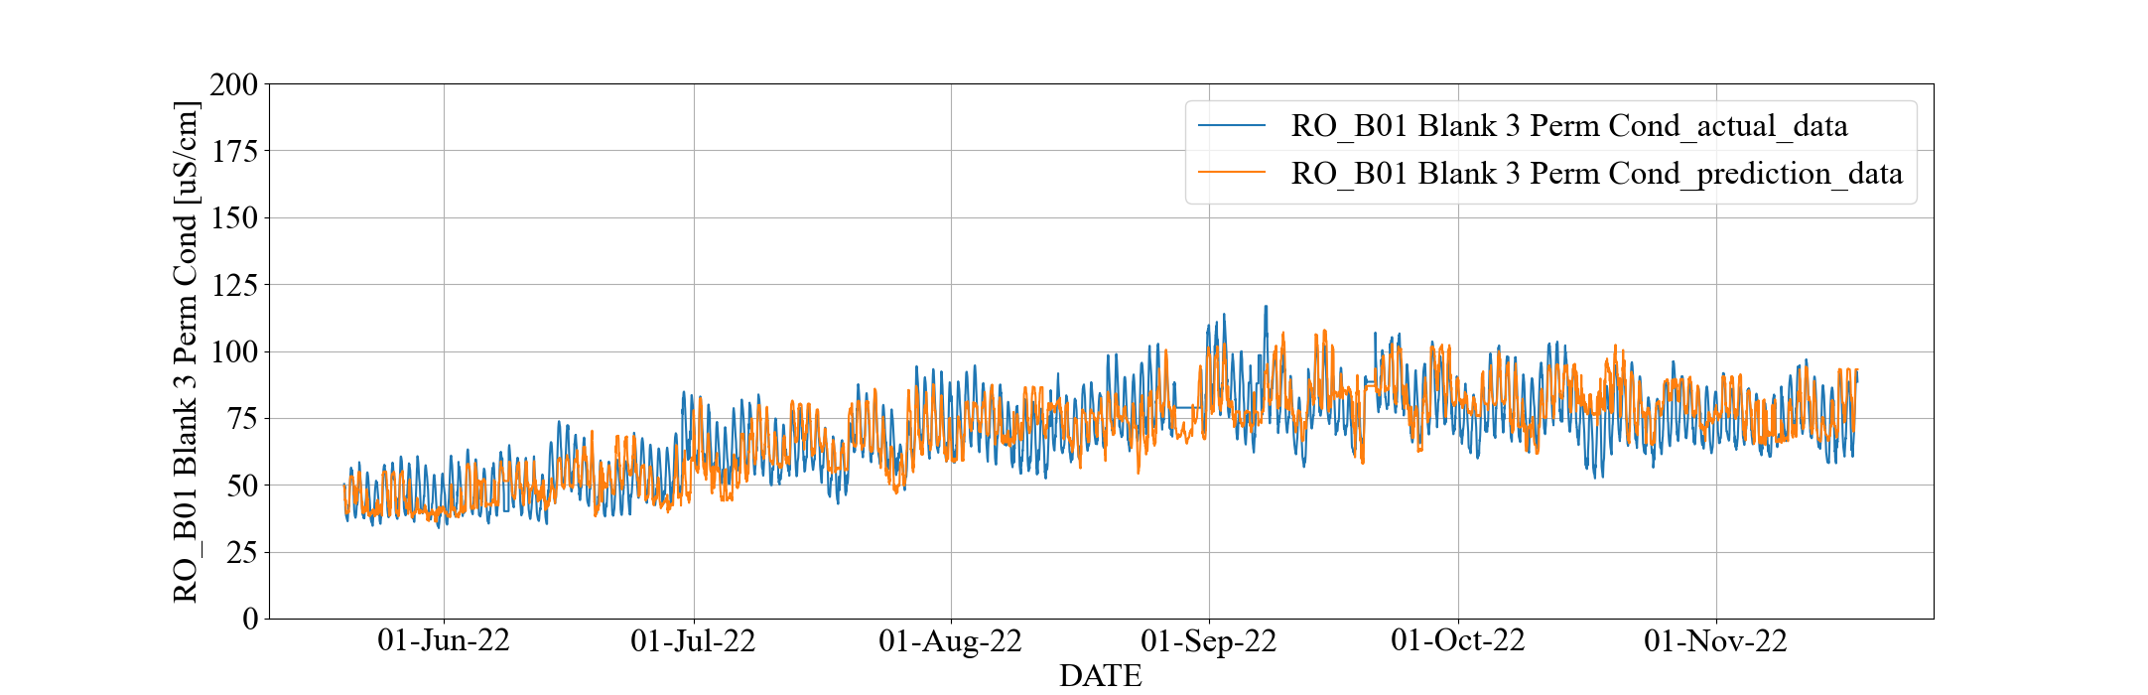

**(c) 3rd Stage Permeate Conductivity**

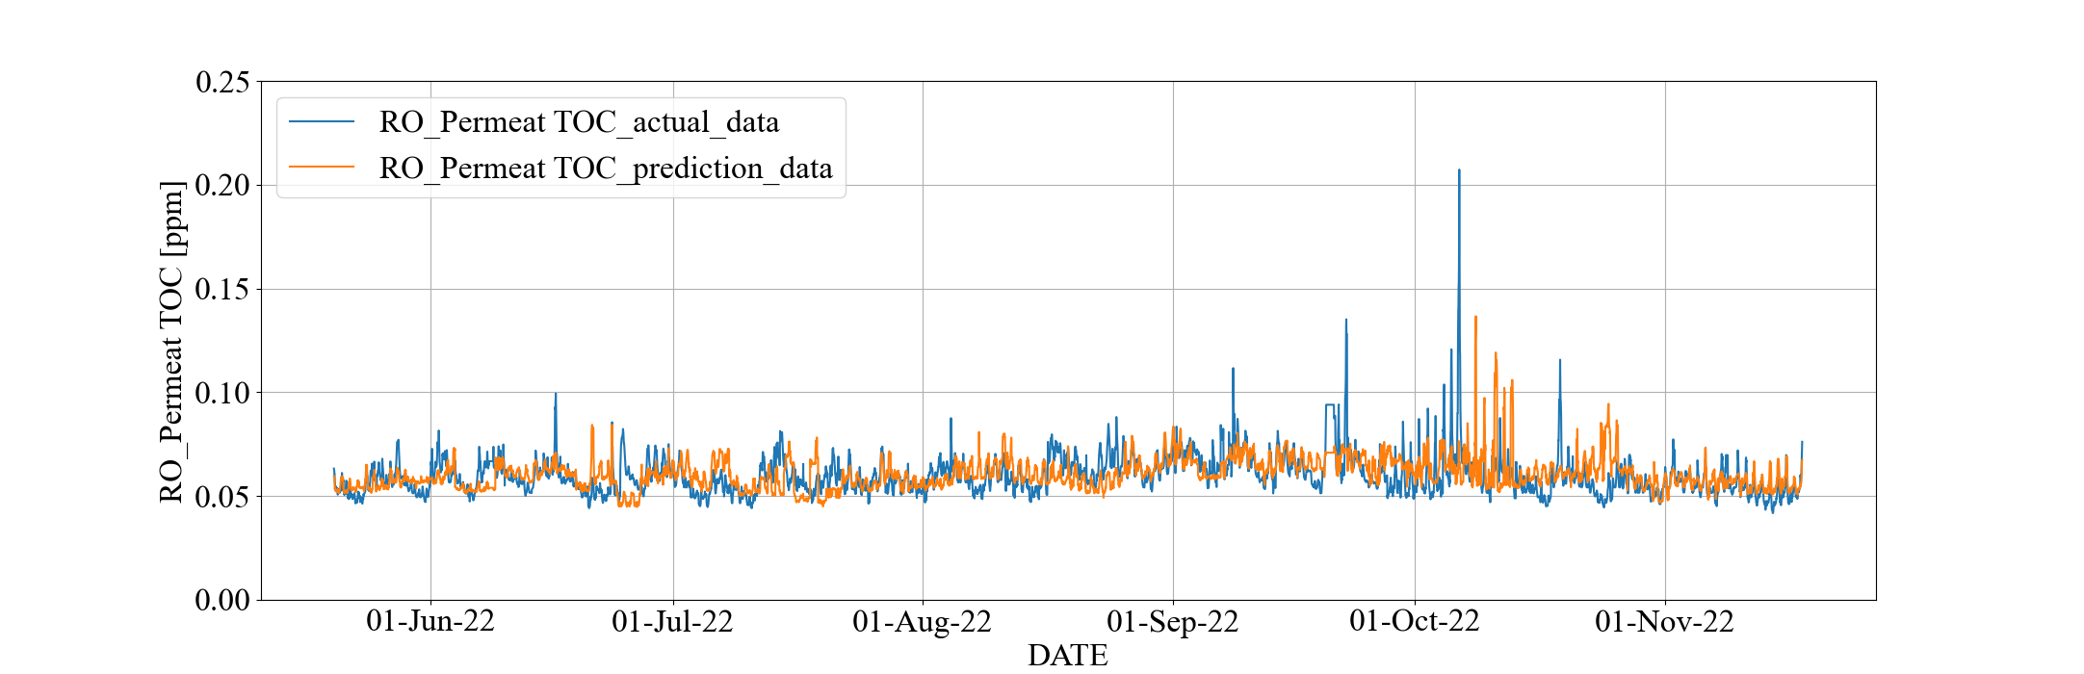

**(d) Permeate TOC**

**Figure 1.2.4: Prediction Trend in All Period with RF (OCWD)**



**(a) Prediction Trend of 3rd Stage Permeate Conductivity with MLR**



**(b) Prediction Trend of 3rd Stage Permeate Conductivity with RF**

**Figure 1.2.5: Comparison of Prediction Trends by MLR and RF (OCWD)**

* 1. **RO Membrane Scaling Estimation Model Using Xact Data**

The purpose of this study is to reduce operating costs by calculating the minimum chemical dosage that can prevent scaling. To achieve the above goals, the following 3 Steps are required.

1. Calculated ion concentration based on ionic equilibrium and solubility products related to Calcium (Ca) and Silica (Si) on membrane surface. Estimated the ionic concentrations at the membrane surface using the concentration polarization equation and mass transfer coefficients.
2. Calculated Ca and Si ionic concentration levels that prevent precipitation on the membrane surface. Estimated the critical Ca and Si concentrations at which these salts do not precipitate at the membrane surface based on the saturation index.
3. Optimizing anti-scalant dosage underway, we are to determine the anti-scalant demand in accordance with the gaps between actual Ca and Si ionic concentrations on the membrane surface and the critical concentration level preventing the precipitation.

The three items above can be classified as scaling estimation methods (A&B) and chemical dosage control method (C). In this section we focus on the implementation method for scaling estimation methods and chemical dosage control method are noted in 1.3.2.2 as a future task.

* + 1. **Method to Estimate Scaling**
* Calculation of ion concentration on membrane surface (Concentration Polarization)

Trace chemicals are measured at the RO feed and permeate by Xact 920 at OCWD. Combining these data with concentration polarization model, we can calculate the concentration at the membrane surface. To derive this model, let $C_{i,j,m}$ be a concentration of solute $m$ at each location and stage, and subscripts “ $i,j,m$” denotes RO stage number (1st, 2nd, 3rd stage), locations (feed, membrane surface, permeate, and brine), and solute type. Considered concentration polarization based on ionic equilibrium and solubility products, the concentration $C_{i,memb,m}$ at the membrane surface is calculated by the following equations.

$$\begin{aligned}C_{i,memb,m}=\left(C_{i,brine,m}-C_{i,perm,m}\right)×e^{\frac{{J_{V}}_{solv_{i}}}{k_{i}}}+C_{i,perm,m}\#\left(1.3.1\right)\end{aligned}$$

where ${J_{v}}_{solv_{i}}$ denotes the permeate flux of solvent and $k_{i,m}$ denotes the mass transfer coefficients. $k_{i,m}$ depends on the permeate fluxes ${J_{v}}_{solv_{i}},{J_{v}}_{salt_{i,m}}$, where ${J_{v}}_{salt_{i,m}}$ denotes permeate flux of solute $m$. Refer to the 3rd quarterly report for detailed concentration polarization calculations. Improvements since 3rd quarterly report are as follows.

* + Mass transfer coefficient $k_{i}$
    - Changed the mass transfer coefficient $k_{i}$ calculation formula from each ion to a representative value for all ions.
  + Osmotic Pressure $π_{i,j}$ (used during the calculation of mass transfer coefficient $k_{i}$)
    - After converting EC measurements to NaCl concentration, osmotic pressure is calculated using Van't Hoff's law.
* Calculation of ion concentration control target value (Saturation Index)

Consider the following chemical equilibrium equation involving compound C, which may precipitate.

$$\begin{aligned}aA+bB↔cC↓+dD\#\left(1.3.2\right)\end{aligned}$$

Saturation Index (SI) is written as follows.

$$\begin{aligned}SI=\log_{10}{(IAP/K)}\#\left(1.3.3\right)\end{aligned}$$

where $K$ represents the equilibrium state based on the theoretical equation, and $IAP$ represents the ion activity product expresses actual state of concentration. $IAP$ and $K$ can be calculated as follows.

$$\begin{aligned}IAP={\left[C\right]}_{act}^{c}{\left[D\right]}_{act}^{d}/{\left[A\right]}_{act}^{a}{\left[B\right]}_{act}^{b}\#\left(1.3.4\right)\end{aligned}$$

$$\begin{aligned}K={\left[C\right]}_{eq}^{c}{\left[D\right]}_{eq}^{d}/{\left[A\right]}_{eq}^{a}{\left[B\right]}_{eq}^{b}\#\left(1.3.5\right)\end{aligned}$$

Note that ${\left[X\right]}_{act}$ means active state of X concentration and ${\left[X\right]}_{eq}$ represents equilibrium state of X concentration.

When $SI>0$ is satisfied, $IAP$ is bigger than $K$, therefore the actual state of equation (1.3.2) is biased toward the right-hand side compared to the equilibrium state, which means that the component C is prone to precipitate. According to the previous research[3] that the risk of scaling progress is high when $SI>0.37$ is satisfied. Therefore, the SI value should be kept below 0.37 with some margin. Given the SI threshold ($0.37-margin$) and other conditions in time series, the corresponding ion concentration can be calculated back from those conditions. In this section, this back calculation is called as inverse operation.The detail of inverse operation is illustrated in Figure 1.3.1. The horizontal axis represents silicon concentration, and the vertical axis expresses saturation index of silica gel. Since there is a one-to-one correspondence between Silicon concentration and Saturation Index assuming other conditions are the same, we can uniquely find a silicon concentration (e.g., yellow and blue dots on vertical axis) that satisfies $SI=0.37-margin$.

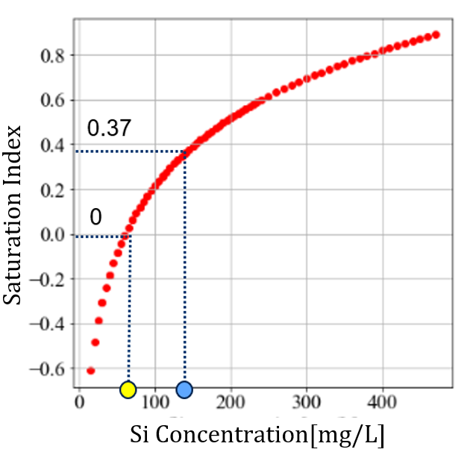

Figure 1.3.1: Example of Inverse Operation

* + 1. **Results**
       1. **Conditions**

The problem setting is as follows.

* Calculation of ion concentration based on ionic equilibrium and solubility products related to Calcium (Ca) and Silica (Si) on membrane surface (Concentration Polarization)

Both Ca and Si cause precipitation and major bring scaling problem. Calculation interval is 30 [min]. Preprocessed data described in Section 1.2.1 was used.

* Calculation of ion concentration control target value (Saturation Index)

The targets of saturation index analysis are the following two reactions.

$$\begin{aligned}CaCO_{3}↔Ca^{2+}+CO_{3}^{2-}\#\left(1.3.6\right)\end{aligned}$$

$$\begin{aligned}SiO_{2}+{2H}_{2}O↔H_{4}SiO_{4}\#\left(1.3.7\right)\end{aligned}$$

We set calculation interval to 1 [day], so we use one-day average as another data preprocessing. In addition, if necessary, annual representative values[4] are utilized (e.g., Na concentration). The calculation flow of ion concentrations satisfying $SI=0.37$ is as follows.Note that this example represents silicon concentration inverse operation procedure.

* + All input values except Si concentration are fixed to actual, calculated, or annual representative values with 1 day moving averages, creating a total of X data where only the Si concentration is varied from 0 ~ 450 [mg/L] (e.g., table 1.3.1).
  + Calculating Saturation Index X times using dedicated software[5], and the Silica concentration closest to “SI = 0.37 – constant” is used as the control target.
  + Repeating 1. and 2. every other day.

An example input data to the SI calculation software on a given day is shown in Table 1.3.1. Only Silicon concentration values represented by red letters change, while the other variables represented by blue are fixed.

**Table 1.3.1: Example Input Data of Calculating Saturation Index (Si inverse operation)**

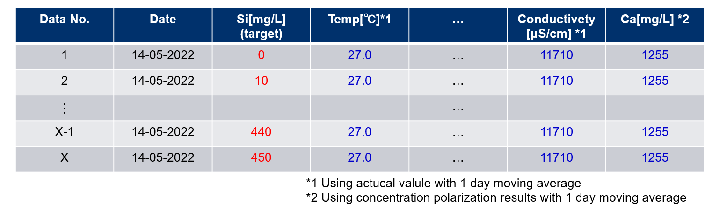

* + - 1. **Results for Concentration Polarization and Saturation Index**

Simulation results are shown in Figure 1.3.2. In each figure, the horizontal axis represents the date, and the vertical axis represents the concentration of Si or Ca. The light blue dotted lines, the blue dotted lines, and the blue solid lines represent the feed concentration at each stage, the brine concentration, and the membrane surface concentration, respectively. The red dotted lines and the orange dotted line are the concentration satisfying SI=0.37 and SI=0, respectively.

Figures 1.3.2 (a) and (b) show the results of Si scaling risk assessment. In both Figures 1.3.2 (a) and (b), the red dotted line, which is the concentration satisfying SI = 0.37, is below the blue solid line, which is the concentration on membrane surface, indicating that silica gel precipitation is unlikely.

In the 3rd Stage, Figure 1.3.2 (b), blue solid line, the concentration on membrane surface, is below the orange line, which is the result of the inverse calculation of SI=0 with a margin of error, around September 2022. This indicates that there is a possibility of reducing the amount of chemical dosage by the difference between the orange line and the solid blue line.

On the other hand, Figures 1.3.2 (c) and (d), which are the results of the Ca scaling evaluation, show that the solid blue line exceeds the dotted red line, indicating the need for increasing chemical dosage.

In order to verify the validity of the above inverse operation results (red and orange dotted lines), we investigated the input data correlated with the inverse computation results. As a result, the correlation between the inverse calculation results and temperature was the highest.

Figure 1.3.3 compares the calculation results and temperatures. There is a strong positive correlation (Figure 1.3.3 (a)) between the inverse results for Si and temperature, and a strong negative correlation (Figure 1.3.3 (b)) between the inverse results for Ca and temperature. This is consistent with the fact that the standard enthalpies for calcite (Eq. 1.3.5) and silica gel (Eq. 1.3.6) formation reactions differ between positive and negative enthalpies. Therefore, the inverse operation results for concentration are consistent with the chemical theory and suggest that the chemical dosage should be determined by paying attention to the temperature. As a future tasks, we aim to calculate the chemical dosage corresponding to the difference between the yellow dotted line and the solid blue line in Figure 1.3.2 (d). Previous studies[6] have shown that there is a strong positive correlation between the chemical dosage and the $\left[Ca^{2+} \right]\left[CO_{3}^{2-}\right]$ concentration in feed water. If modeling between chemical input and ion concentrations in water could be done, the optimal chemical dosage could be calculated by incorporating Scaling model within the optimization algorithm described in Section 1.4.

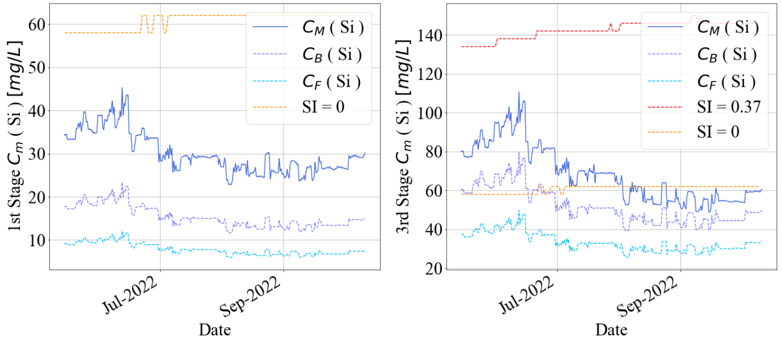

**(a) Si concentration at 1st Stage (b) Si concentration at 3rd Stage**

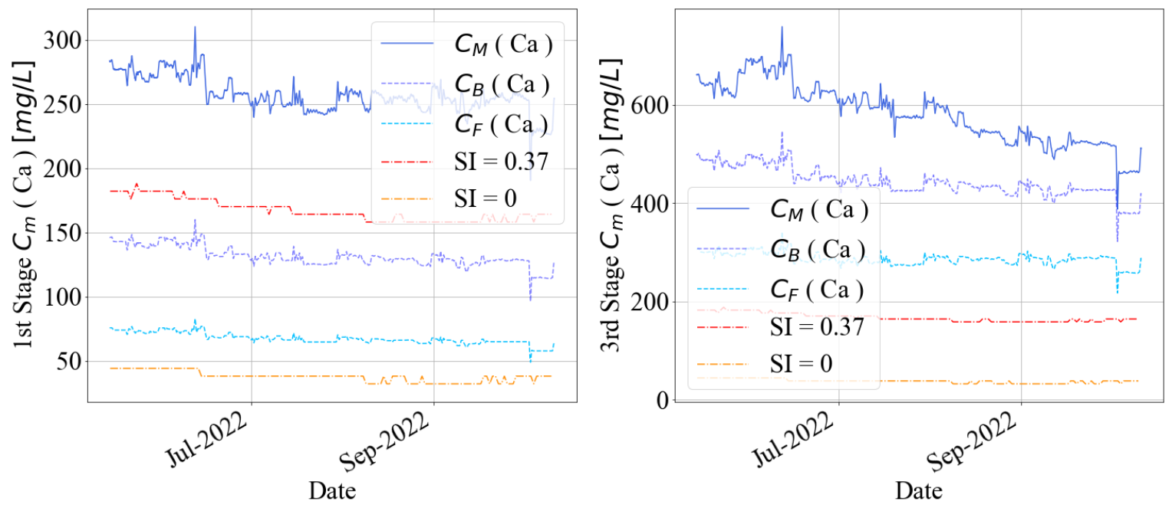

**(c) Ca concentration at 1st Stage (d) Ca concentration at 3rd Stage**

**Figure 1.3.2: Comparison of Concentrations Between Feed and Membrane Surface**

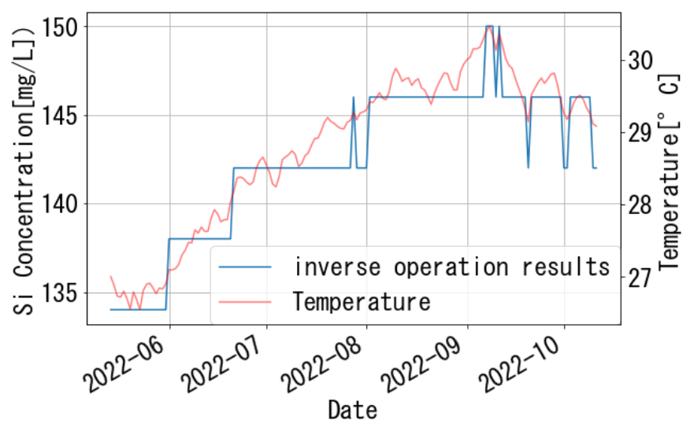

**(a) Si concentration at 3rd Stage**

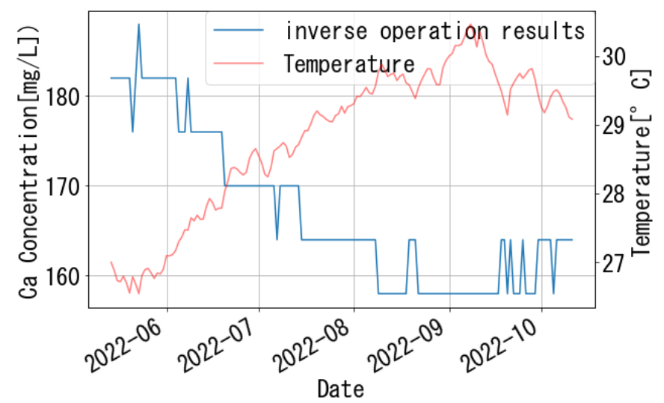

**(b) Ca concentration at 3rd Stage**

**Figure 1.3.3: Comparison of Concentrations and Temperature**

* 1. **RO Optimization Calculation**
     1. **Optimization Problem for RO Operational Scheduling**

RO optimization problem is formulated as a scheduling problem. The operational schedule is denoted by $x_{i}$ ($i=1,2,…, n$). $x_{i}\left[t\right]$ denotes the $i$-th variable schedule at time $t$, $x_{i}=(x_{i}\left[1\right], x_{i}\left[2\right],…, x_{i}\left[L\right])$ denotes the $i$-th variable schedule in all periods, $L$ denotes the length (step size) of the optimization period, and $n$ denotes the number of variables.

The objective function is sum of the threshold inhibitor usage and sulfuric acid usage during the optimization period. The constraint conditions are given by lower and upper limits and water quality standard limits based on Logarithmic Reduction Value (LRV). Table 1.4.1 shows only the major constraints. LRV $γ_{X}$ of water quality data $X$ (e.g., electric conductivity and TOC) as follows:

$$\begin{aligned}γ_{X}\left[t\right]=\log_{10}\left(\frac{X_{feed}[t]}{X_{perm}[t]}\right); t=1,2,…,L\#\left(1.4.1\right)\end{aligned}$$

Here, $X_{feed}$ denotes RO feed quality data $X$ and $X_{perm}$ denotes RO combined permeate quality data $X$. The constraint’s parameters shown in Table 1.4.1 are basic values, modified somewhat in some cases.

The mathematical prediction model is based on the Multiple Linear Regression Model (MLR) because the amount of calculation time using the Random Forest is about 300 times longer than MLR in the optimization.

**Table 1.4.1: Major Constraints (basic upper/lower limit and LRV)**

|  |  |  |  |
| --- | --- | --- | --- |
| **Description** | **Units** | **Lower** | **Upper** |
| Stage 1 Permeate EC | $$μS/cm$$ | 10 | 95 |
| Stage 2 Permeate EC | $$μS/cm$$ | 20 | 200 |
| Stage 3 Permeate EC | $$μS/cm$$ | 60 | 350 |
| Permeate Combined EC | $$μS/cm$$ | 60 | 350 |
| Permeate Combined TOC | ppm | 0 | 0.15 |
| Permeate Combined EC LRV | - | 1.5 | 2.3 |
| Permeate Combined TOC LRV | - | 1.5 | 2.5 |

* + 1. **RO Optimization Module**

We implemented the RO optimization module by writing Python source code from scratch. This module solves the above optimization problem by using the optimization algorithm and calculate the optimized RO operational schedule.

Figure 1.4.1 shows the functional configuration and flow chart of RO optimization module. The procedure consists of 5 steps; step 1 is data pre-processing, step 2 is model construction, step 3 is model validation, step 4 is optimization, and step 5 is data post-processing. We will implement the RO optimization system in the pilot-scale based on this module.

This problem is classified as constrained and black-box problem. We constructed and used an optimization algorithm by combining SHADE[7] and Feasibility Rule[8] for solving the problem. SHADE is known to be the best unconstrained black-box optimization in the optimization field recently and often used in the BBOB competition[9]. Feasibility Rule is one of the constraint handling techniques, which enables unconstrained optimization algorithms to be applied to the constrained optimization.

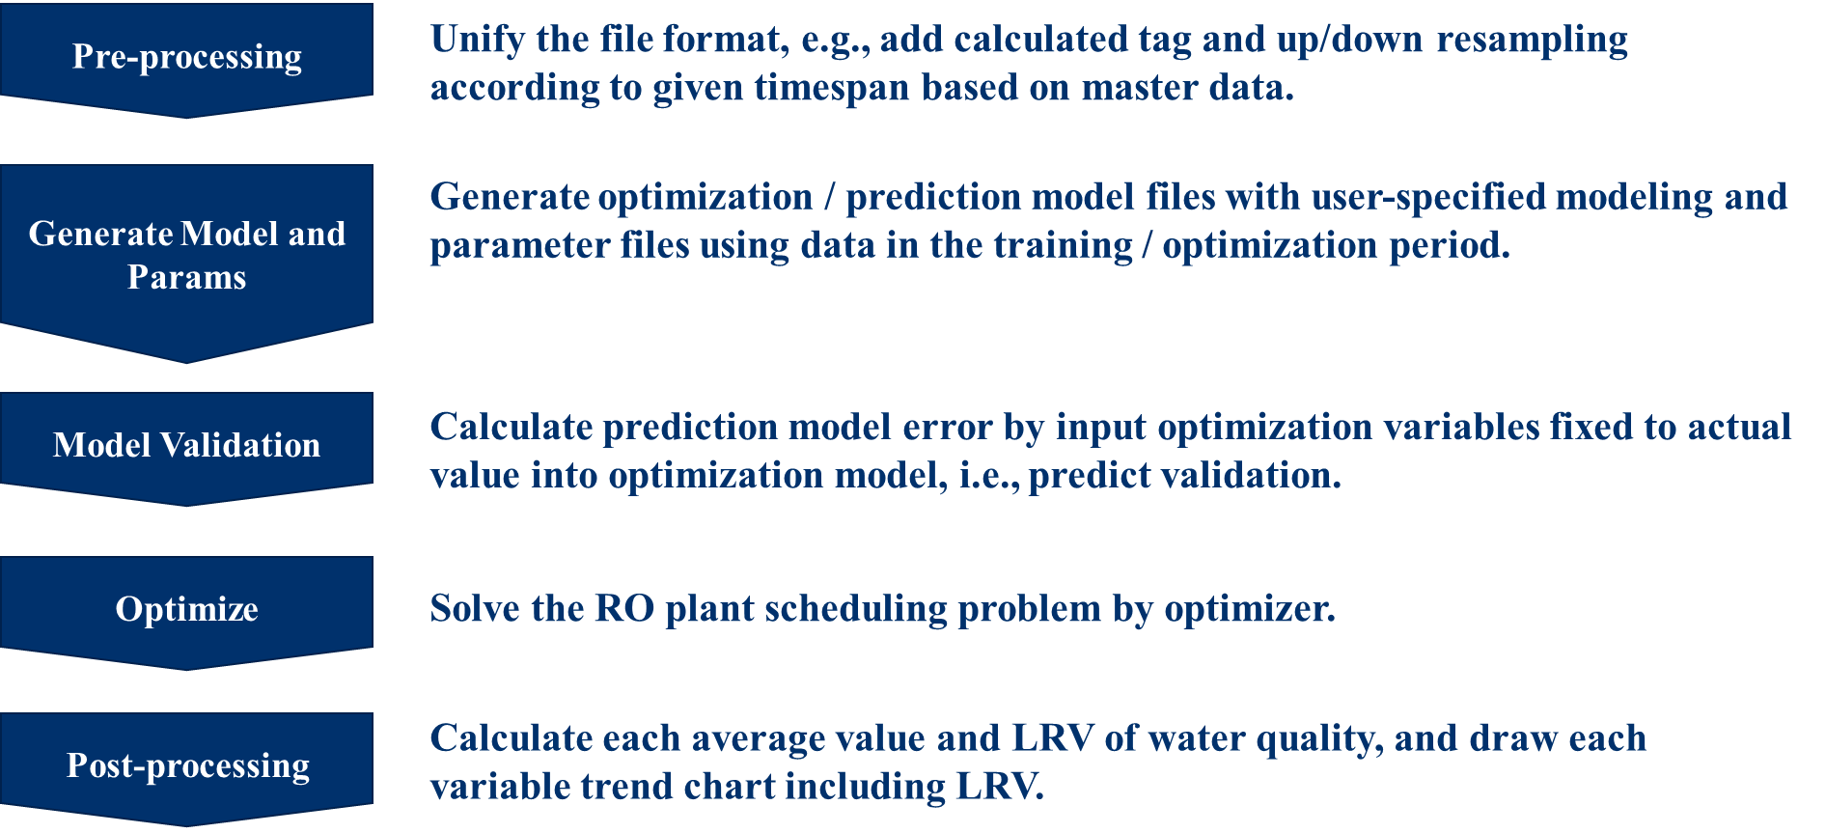

**Figure 1.4.1: Functional Configuration and Flow Chart of RO Optimization Module**

* + 1. **Optimization Results**

This part shows the optimization results. The method trains one week's data and optimizes the following week. The training and optimization periods are shifted sequentially and the entire of the consolidated optimization period is from June 17th to July 22nd, 2022, i.e., 5 weeks in this report.

The prediction results by the RO optimization module are shown in Figures 1.4.2 and 1.4.3. The prediction is calculated by using connected all unit models as shown in Figure 1.1.3. Figure 1.4.2 is the prediction trend of permeate combined TOC and LRV of that, and Figure 1.4.3 is the prediction trend of permeate combined conductivity (EC) and LRV of that. From these figures, the permeate EC and TOC prediction performances are good except the 4th week.

Figure 1.4.4 is the scatter chart between inhibitor and combined permeate TOC in the optimization period. In Figure 1.4.4, the color of the marker means the actual data for each week. Figure 1.4.4 shows the coefficient of determination $R^{2}$ between inhibitor and permeate TOC is 0.02, i.e., they are basically weakly related. Additionally, inhibitor is significantly declining in the 4th week and the tendency between training and optimization period is different. Therefore, the predicted water quality value tends to change excessively in response to changes in input variables.

The optimization results are shown in Figures 1.4.5, 1.4.6, and 1.4.7. Figure 1.4.5 is optimized trend of chemical dosage, i.e., sulfuric acid and inhibitor, Figure 1.4.6 is optimized trend of permeate combined TOC and LRV of that, and Figure 1.4.7 is optimized trend of permeate EC and LRV of that. From these figures, the optimal values of EC and TOC satisfy upper and lower limit constraints while the optimal value of inhibitor is lower than the actual value, i.e., chemical dosing cost decreases. While inhibitor decreases uniformly, EC and TOC can increase or decrease depending on each week due to instability of the models caused by weak relationship described above. To improve the relationship, it needs to introduce the RO membrane scaling model to the optimization model and use stably measured online data.

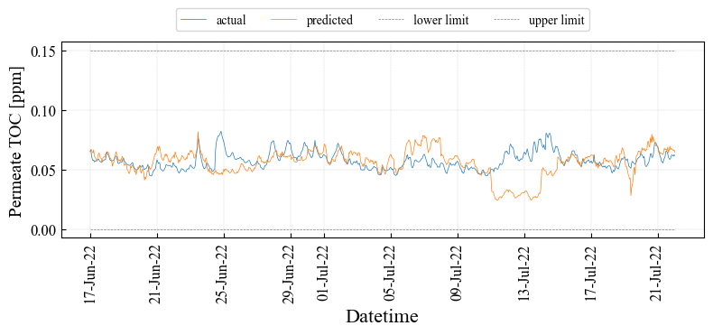

1. **Permeate Combined TOC**

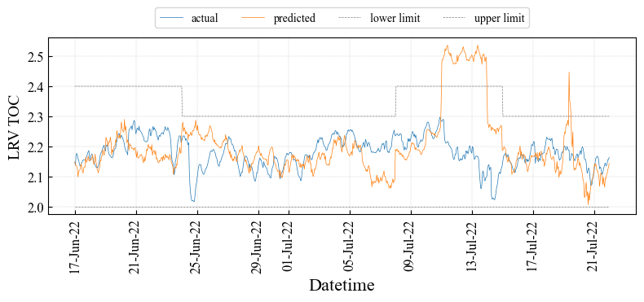

1. **LRV of Permeate Combined TOC**

**Figure 1.4.2: Prediction Results of TOC in RO Module (OCWD)**

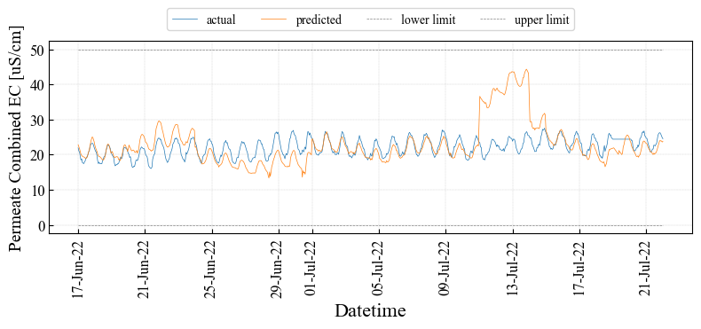

1. **Permeate Combined EC**

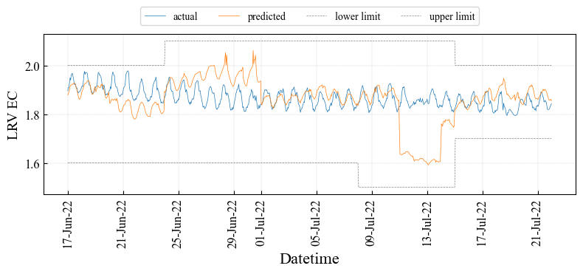

1. **LRV of Permeate Combined EC**

**Figure 1.4.3: Prediction Results of EC using RO Module (OCWD)**



**Figure 1.4.4: Scatter Chart between Inhibitor and Permeate TOC (OCWD)**

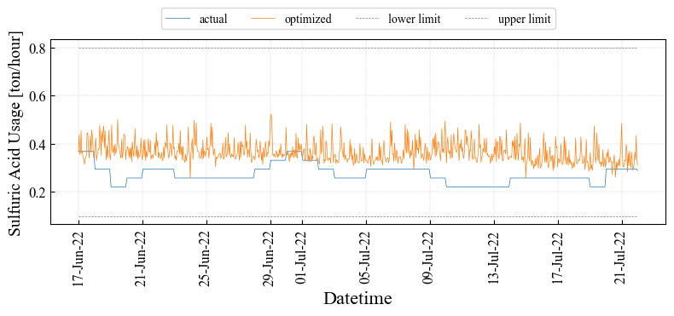

1. **Sulfuric Acid Usage**

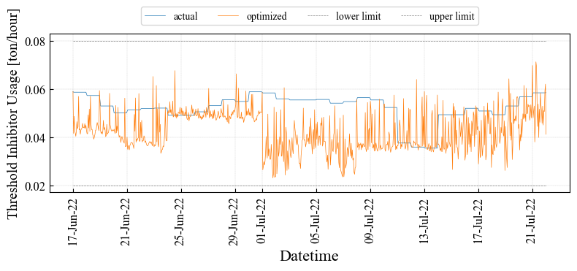

1. **Inhibitor Usage**

**Figure 1.4.5: Optimization Results of Chemical Dosage using RO Module (OCWD)**

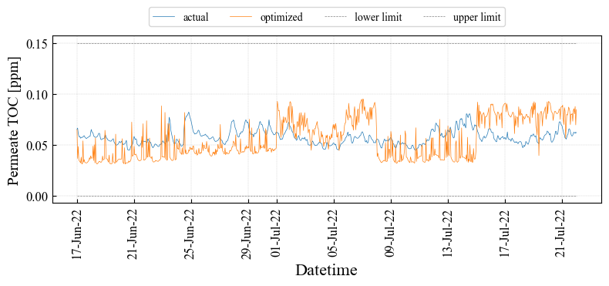

1. **Permeate Combined TOC**

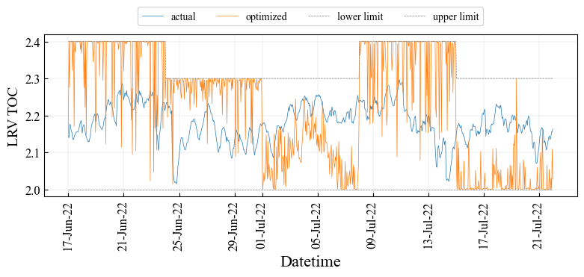

1. **LRV of Permeate Combined TOC**

**Figure 1.4.6: Optimization Results of TOC using RO Module (OCWD)**

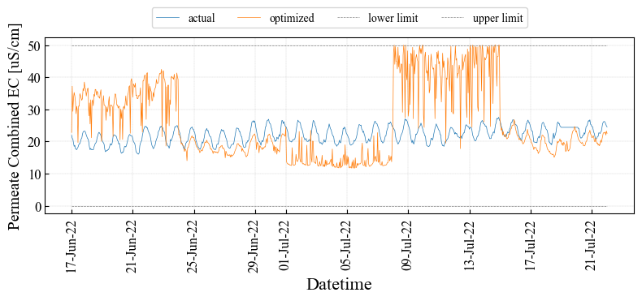

1. **Permeate Combined EC**

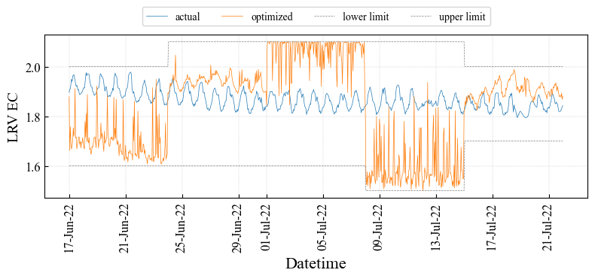

1. **LRV of Permeate Combined EC**

**Figure 1.4.7: Optimization Results of EC using RO Module (OCWD)**

* + 1. **Optimization Effects**

The optimization effects are shown in Table 1.4.2. The cost reduction is about $71.1 per day i.e., $0.03M per year by optimization. Even though the RO optimization framework works correctly, there is room for improvement in the optimization model including the prediction model. To improve the relationship, it needs to introduce the RO membrane scaling model to the optimization model and use stably measured online data as discussed in the previous section.

**Table 1.4.2: Optimization Effect (OCWD)**

|  |  |  |  |  |  |  |
| --- | --- | --- | --- | --- | --- | --- |
| **Description** | **Units** | **Actual** | **Optimized** | **Diff**  **(Opt-Act)** | **Diff – Err.** | **Cost**  **[$/day]** |
| Acid | ton/hour | 0.27 | 0.36 | $+$ 0.09 | $+$ 0.09 | $+$ 541 |
| Inhibitor | ton/hour | 0.27 | 0.36 | $-$ 0.01 | $-$ 0.01 | $-$ 612 |
| EC | $$μS/cm$$ | 22.1 | 25.8 | $+$ 3.70 | $+$ 2.92 |  |
| TOC | ppm | 0.057 | 0.055 | $-$ 0.002 | $-$ 0.001 |  |
| LRV EC | - | 1.87 | 1.84 | $-$ 0.03 | $-$ 0.02 |  |
| LRV TOC | - | 2.18 | 2.22 | $+$ 0.04 | $+$ 0.02 |  |
| Total |  |  |  |  |  | 71.1 |

* 1. **Future Tasks**

The optimization result represented in this report considers only the water quality model. The optimization variables, which are the ones we can manipulate, are the amounts of sulfuric acid and anti-scalant dosage. However, the main purpose of these chemicals is to prevent the progress of scaling for a long-term, and they do not have strong effects on the water quality behavior in a short-term. For this reason, no or little cost improvement is found in the optimization with only water quality model. We need to integrate a membrane scaling model into the optimization to obtain a substantial and practical benefit through our optimization. We are currently developing the long-term optimization approach that considers ionic equilibrium and solubility products related to Calcium and Silica on membrane concentration polarization layer. In online demonstration of Year 2, we recommend measuring the physicochemical responses of differential and transmembrane pressures in RO membrane as the effect of anti-scalant dosage rate on the RO scaling that reflects in our model creation.

In the development of the online optimization system, reducing computational cost could be a challenge. The calculation time for the Random Forest (RF) prediction is much longer (about 300 times) than the Multiple Linear Regression (MLR). In case a black-box optimization algorithm evaluates the objective function for thousands of times and the objective function computes the prediction for hundreds of timesteps, the prediction requires evaluation loops at hundreds of thousands of times. This means that if a model with MLR takes 10 minutes to optimize, a model with RF takes 3,000 minutes (50 hours).

2. **Desktop Analysis based on LVMWD**
   1. **RO Optimization Overview**

Basic optimization story is to decrease the chemical dosing cost (e.g., chloramines) while satisfying water quality standards or monitoring RO membrane fouling. The problem is formulated as scheduling problem.

* + 1. **Flowchart**

Figure 2.1.1 shows the flow chart based on the RO system configuration. The RO system configuration and tag name list of LVMWD is provided as “Additional Materials A1” at the end of this report. Figure 2.1.1 (a) is the flow chart limited to the part related to permeate TOC prediction and Figure 2.1.1 (b) is the flow chart limited to the part related to permeate EC prediction.

In Figure 2.1.1, the arrows and objects are same meaning as the case of OCWD (in Figure 1.1.2). Especially, output data from a hexagon object toward a square object is calculated by the prediction models described in the later sections.

* + 1. **Formulation Optimization Problem**

Table 2.1.1 shows the optimization variable list in the LVMWD optimization model. “Optimization Variable”, “Fixed Parameter”, and “Intermediate Variable” have the same meaning as in the case of OCWD. In LVMWD optimization model, the optimization variable is UF filtrate total chlorine, and the intermediate variables are the permeate electric conductivity (EC) at stage 1, stage 2, and stage 3, combined permeate EC, and combined permeate TOC calculated by water quality prediction model.



1. **RO Total Flow Chart (Permeate TOC)**



1. **RO Each Stage Flow Chart (Permeate EC)**

**Figure 2.1.1: Flow Chart for RO Optimization Calculation (LVMWD)**

**Table 2.1.1: Optimization Variable List (LVMWD)**

|  |  |  |  |
| --- | --- | --- | --- |
| ID No. | Description | Units | Opt. Variable / Fixed Parameter |
| ID0000 | UF Filtrate Total Chlorine | ton/hour | Optimization Variable |
| ID0001 | Feed EC | $$μS/cm$$ | Fixed Parameter |
| ID0002 | Feed TOC | mg/L | Fixed Parameter |
| ID0003 | Feed Temperature | $$℉$$ | Fixed Parameter |
| ID0004 | Feed pH | - | Fixed Parameter |
| ID0100 | Stage 1 Feed Pressure | psi | Fixed Parameter |
| ID0101 | Stage 1 Feed Flow Rate | gpm | Fixed Parameter |
| ID0102 | Stage 1 Permeate Flow Rate | gpm | Fixed Parameter |
| ID0200 | Stage 2 Feed Flow Rate | gpm | Fixed Parameter |
| ID0201 | Stage 2 Permeate Flow Rate | gpm | Fixed Parameter |
| ID0300 | Stage 3 Feed Pressure | psi | Fixed Parameter |
| ID0301 | Stage 3 Feed Flow Rate | gpm | Fixed Parameter |
| ID0302 | Stage 3 Permeate Flow Rate | gpm | Fixed Parameter |
| ID1000 | Stage 1 Permeate EC | $$μS/cm$$ | Intermediate Variable |
| ID2000 | Stage 2 Feed EC |  | Intermediate Variable |
| ID2001 | Stage 2 Permeate EC |  | Intermediate Variable |
| ID3000 | Stage 3 Feed EC |  | Intermediate Variable |
| ID3001 | Stage 3 Permeate EC | $$μS/cm$$ | Intermediate Variable |
| ID4000 | Combined Permeate EC | $$μS/cm$$ | Intermediate Variable |
| ID4001 | Combined Permeate TOC | mg/L | Intermediate Variable |

* 1. **Water Quality Prediction**

The water quality models are used as constraints in the overall optimization of RO operation. The total chlorine is minimized under the condition that the water quality estimated by the model satisfies the water quality standard values. In this chapter we constructed water quality prediction models and validated the accuracy of the created model as in the case of OCWD.

* + 1. **Outliers Removal**

The preprocessing procedure is the same as the case of OCWD. Details of the step 1 and 2 parameters for the LVMWD data can be found in “Additional Materials A3” at the appendix of this report.

Figure 2.2.1 (a)-(f) show the raw and preprocessed trends of the feed pressure, the feed TOC, and the feed tempreture from July 2020 to September 2022. Figures 2.2.1 (a) and (b) show the results of preprocessing using only step 1. Figures 2.2.1 (c)-(f) show the results of preprocessing using step 2 in addition to step 1. We can see that all spiky outliers were removed and the essential behavior of the data is extracted.

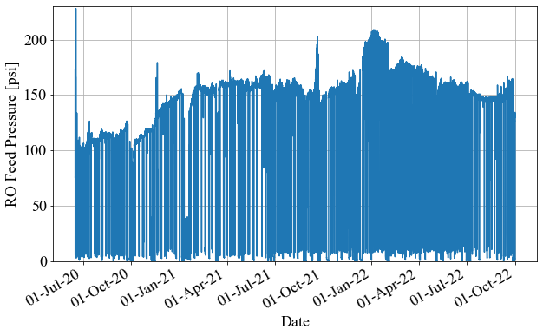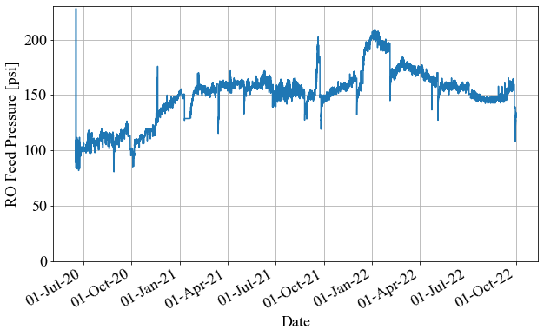

**(a) Raw Feed Pressure (b) Feed Pressure**

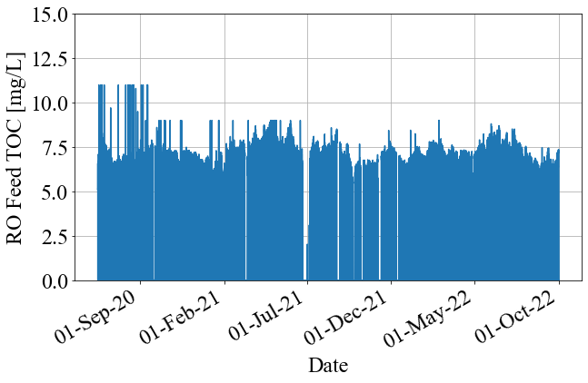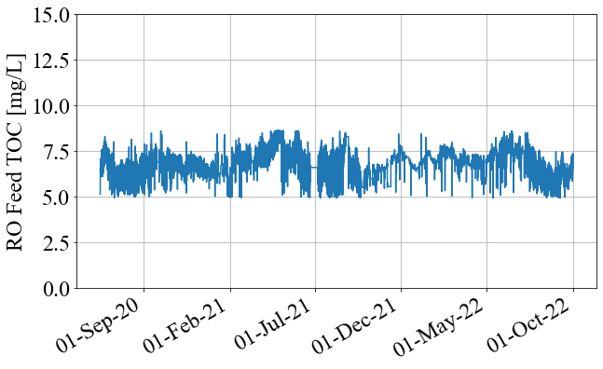

**(c) Raw Feed TOC (d) Feed TOC**

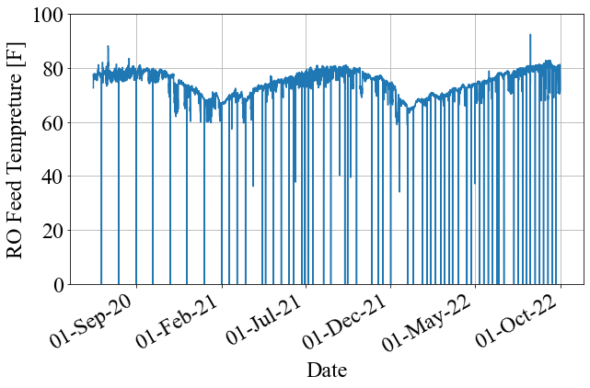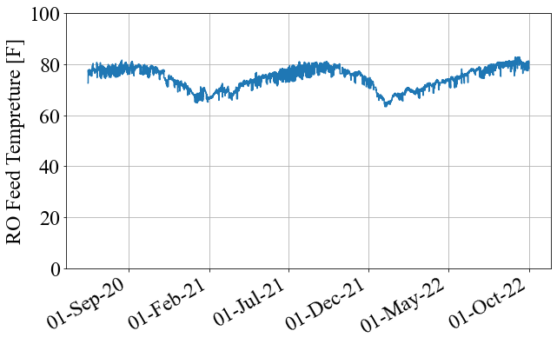

**(e) Raw Feed Temperature (f) Feed Temperature**

**Figure 2.2.1: Raw and Preprocessed Data (LVMWD)**

* + 1. **Prediction Method**

Two methods, the multiple linear regression (MLR) and the random forest (RF), were evaluated for prediction accuracy of the permeate electric conductivity (EC) and permeate TOC as in the case of OCWD.

As in the analysis of OCWD, RF is expected to have better prediction accuracy due to nonlinear relationships that cannot be expressed by MLR.

We received data measured at 1-minute or 1-day intervals in the RO unit from LVMWD. The RO system configuration of LVMWD is provided in “Additional Materials A1” at the appendix of this report. Permeate EC and permeate TOC are considered as indicators of RO membrane scaling and have water quality standards to be satisfied. Permeate EC is measured at each stage of permeate in the RO unit and the permeate TOC is measured after the permeate flows from the three stages of the whole RO are merged. Therefore, we constructed four models for permeate ECs at 1st, 2nd, and 3rd stages and permeate TOC at the whole RO.

We used continuous data from July 1st, 2021 to July 27th, 2022 and the other period is excluded because it contains uncontinous data or was under significantly different plant operation conditions. 1-minute data was resampled to 30-minute data for water quality prediction.

The set of training and evaluation periods slides forward sequentially as in the case of OCWD.

The evaluation indexes are Mean Absolute Percentage Error (MAPE) $E_{MAPE}$ [%] and Root Mean Percentage Error (RMSE) $E_{RMSE}$ in the same way as OCWD.

Table 2.2.1 shows the variable list for each water quality prediction model. “X” means an explanatory variable, “Y” means a predicted variable, and “*” means a calculated variable. Tag name list is provided in “Additional Materials A1” at the appendix of this report. Details of calculated variable can be found in “Additional Materials A4” at the appendix of this report.

**Table 2.2.1: Variable List of each water quality prediction model (LVMWD)**

|  |  |  |  |  |
| --- | --- | --- | --- | --- |
| Variable Name | Stage1  Permeate  EC | Stage2  Permeate  EC | Stage3  Permeate  EC | Permeate  TOC |
| RO Stage 1 Feed Pressure | X |  |  | X |
| RO Feed EC | X |  |  | X |
| RO Feed Flow * | X |  |  | X |
| RO Feed Temperature | X | X | X | X |
| RO Feed pH | X |  |  | X |
| UF Filtrate Total Chlorine | X | X | X | X |
| RO Stage 2 Feed EC * |  | X |  |  |
| RO Stage 2 Feed Flow * |  | X |  |  |
| RO Stage 3 Feed Pressure |  |  | X | X |
| RO Stage 3 Feed EC * |  |  | X |  |
| RO Stage 3 Feed Flow * |  |  | X |  |
| RO Feed TOC |  |  |  | X |
| RO Stage 1 Permeate EC | Y |  |  |  |
| RO Stage 2 Permeate EC |  | Y |  |  |
| RO Stage 3 Permeate EC |  |  | Y |  |
| RO Combined Permeate TOC |  |  |  | Y |

* + 1. **Prediction Results**

Table 2.2.2 shows prediction accuracy result by MLR. The trends of the prediction results are shown in Figure 2.2.2 (a)-(d). In Figure 2.2.2, blue lines indicate preprocessed actual data and orange lines indicate predicted data.

Table 2.2.3 shows prediction accuracy result by RF. The trends of the prediction results are shown in Figure 2.2.4 (a)-(d). In Figure 2.2.3, blue lines indicate preprocessed actual data and orange lines indicate predicted data.

RF predict water qualities better than MLR. Figure 2.2.4 re-posts the predicted trends of 1st Stage Permeate Conductivity by MLR and RF. This Figure shows that the values during the periods marked with dashed red circles were predicted far off from preprocessed actual data comparing to the prediction during corresponding period by RF. This difference is considered to come from the effect of extrapolation. RF only predicts within the range of variables observed during training period. On the other hand, MLR can output predicted values beyond the range of value observed during training period as in the case of OCWD.

**Table 2.2.3: Prediction Accuracy Result by Random Forest (LVMWD)**

|  |  |  |  |  |
| --- | --- | --- | --- | --- |
| **Index** | **Stage1**  **Permeate EC** | **Stage2**  **Permeate EC** | **Stage3**  **Permeate EC** | **Permeate TOC** |
| **RMSE** | 0.88 [uS/cm] | 1.40 [uS/cm] | 2.02 [uS/cm] | 0.017 [mg/L] |
| **MAPE** | 3.20 [%] | 4.37 [%] | 4.06 [%] | 15.02 [%] |

**Table 2.2.2: Prediction Accuracy Result by MLR (LVMWD)**

|  |  |  |  |  |
| --- | --- | --- | --- | --- |
| **Index** | **Stage1**  **Permeate EC** | **Stage2**  **Permeate EC** | **Stage3**  **Permeate EC** | **Permeate TOC** |
| **RMSE** | 1.88 [uS/cm] | 2.46 [uS/cm] | 2.30 [uS/cm] | 0.023 [mg/L] |
| **MAPE** | 5.24 [%] | 5.59 [%] | 4.70 [%] | 18.46 [%] |

図番号

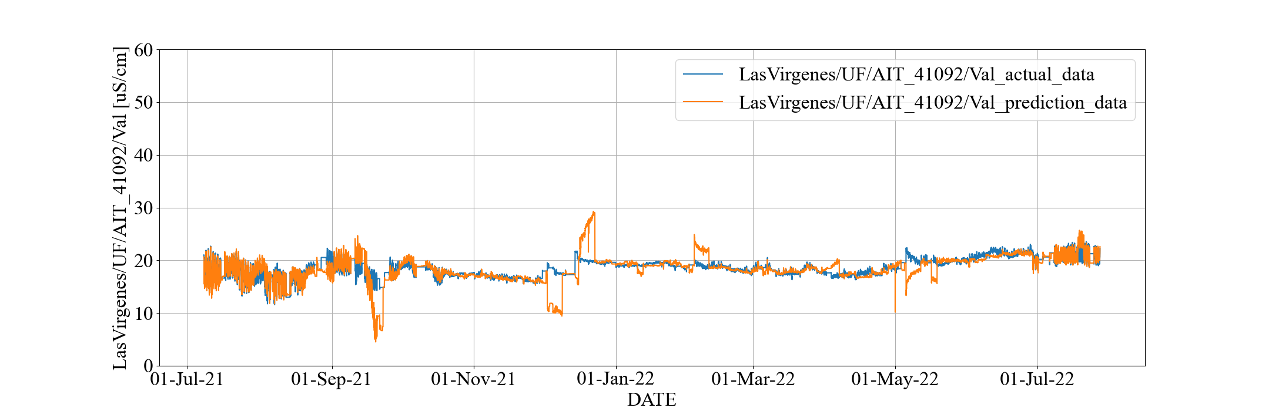

**(a) 1st Stage Permeate Conductivity**

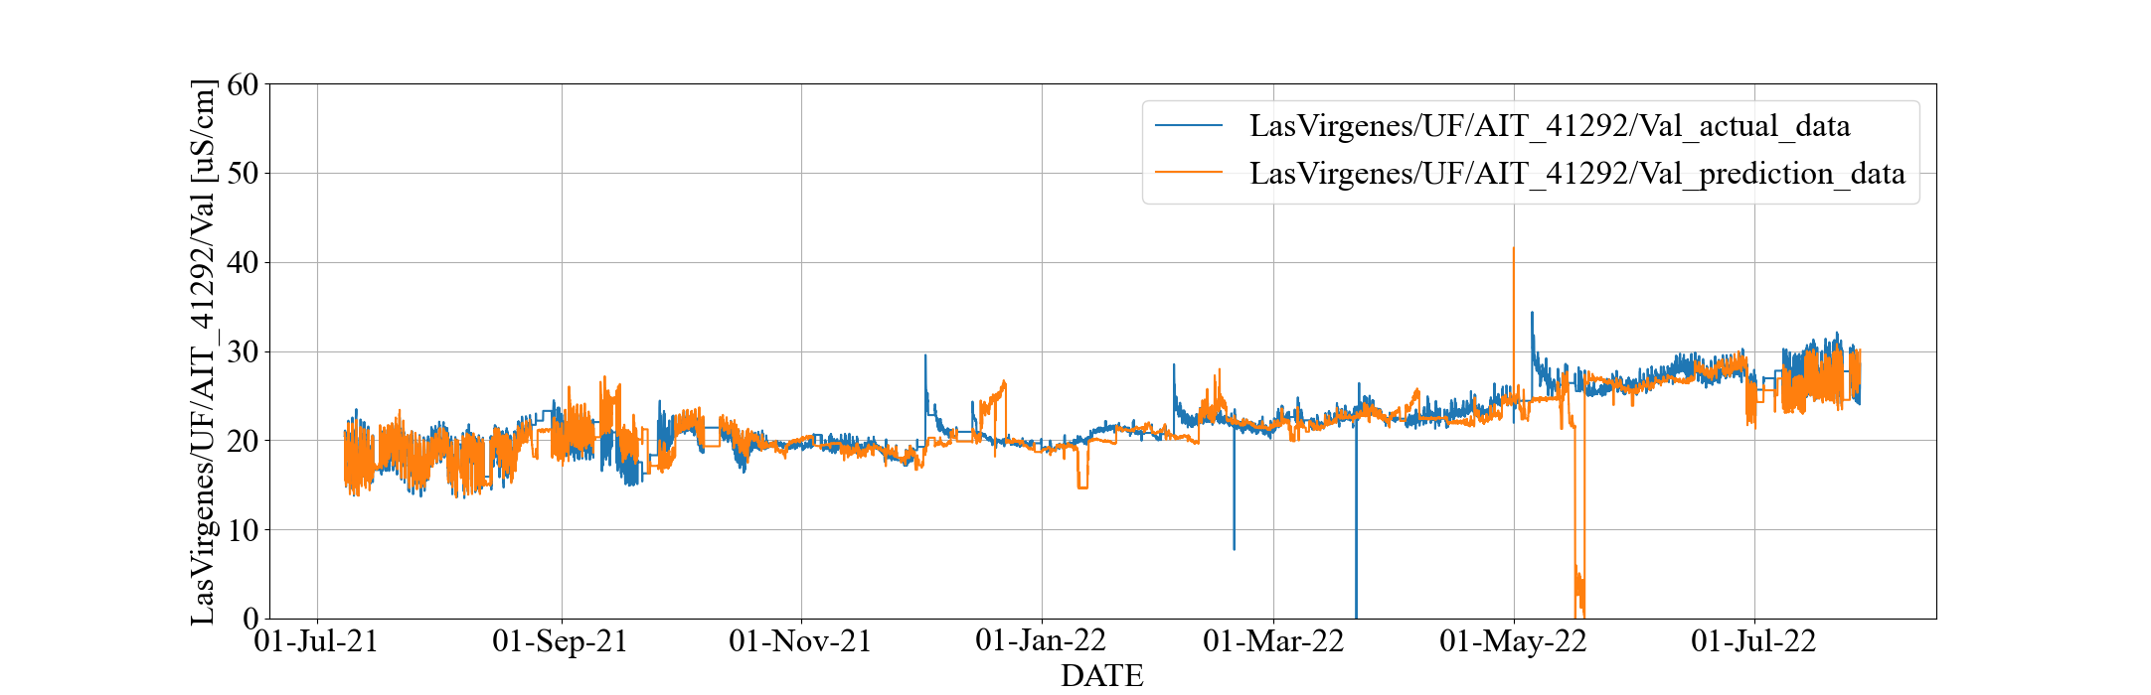

**(b) 2nd Stage Permeate Conductivity**

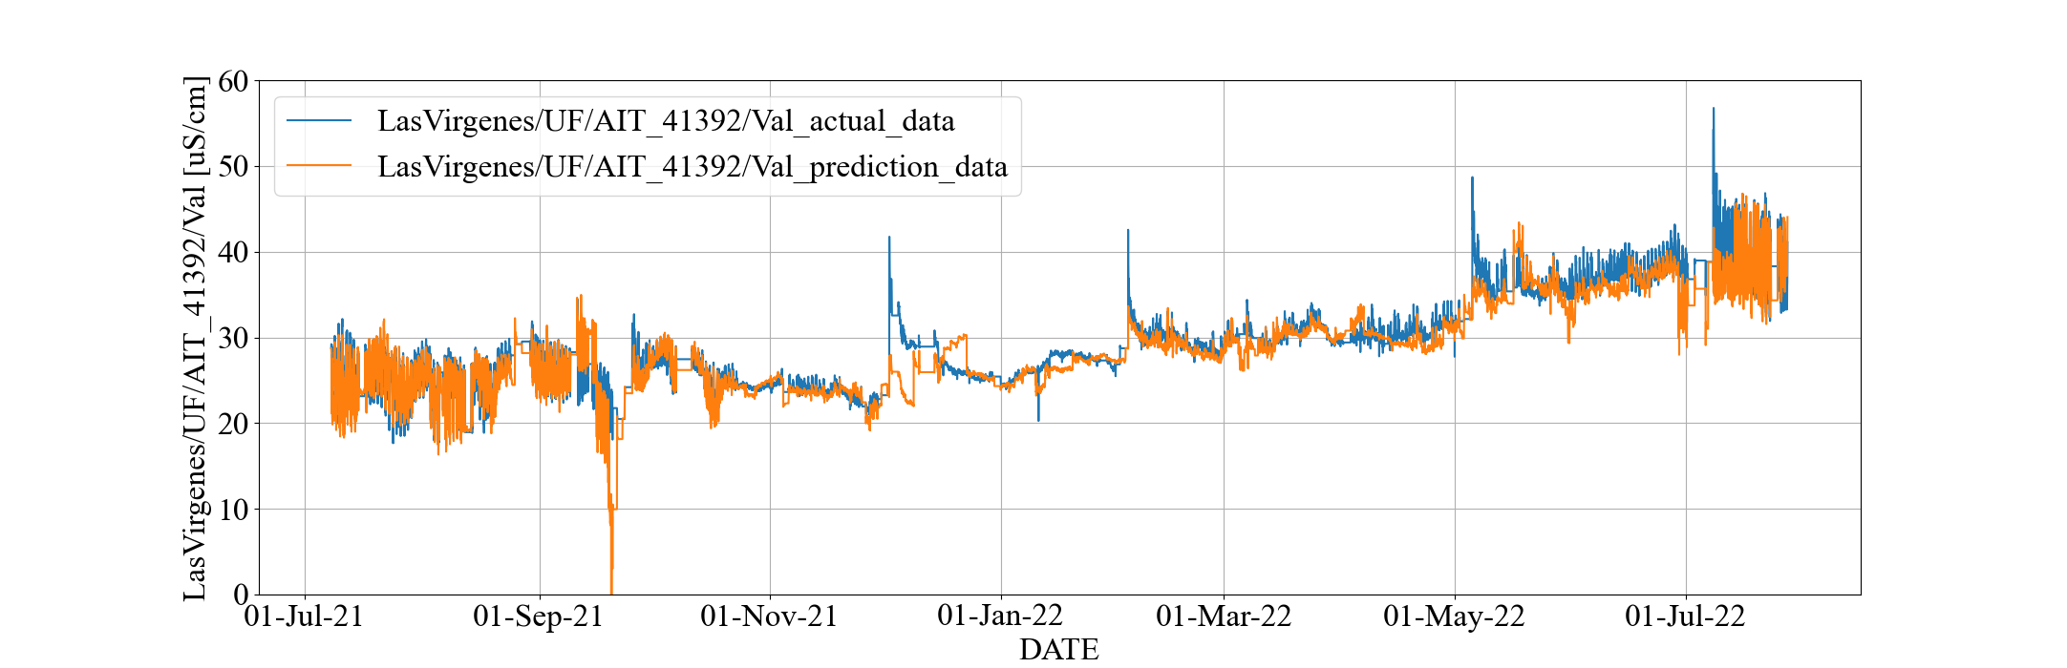

**(c) 3rd Stage Permeate Conductivity**

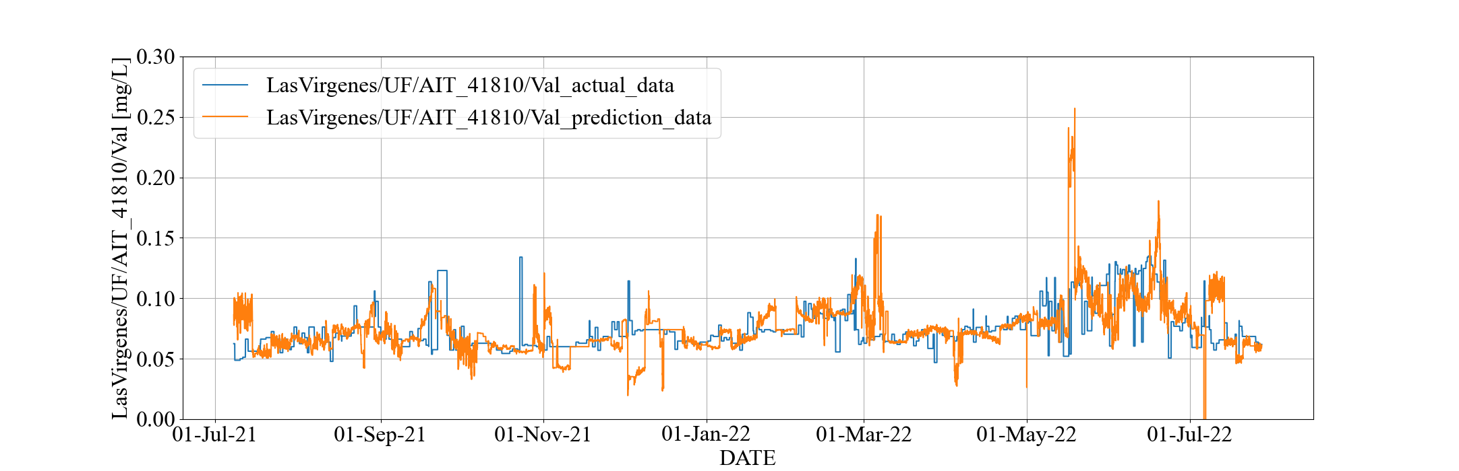

**(d) Permeate TOC**

**Figure 2.2.2: Prediction Trend in All Period with MLR (LVMWD)**

図番号

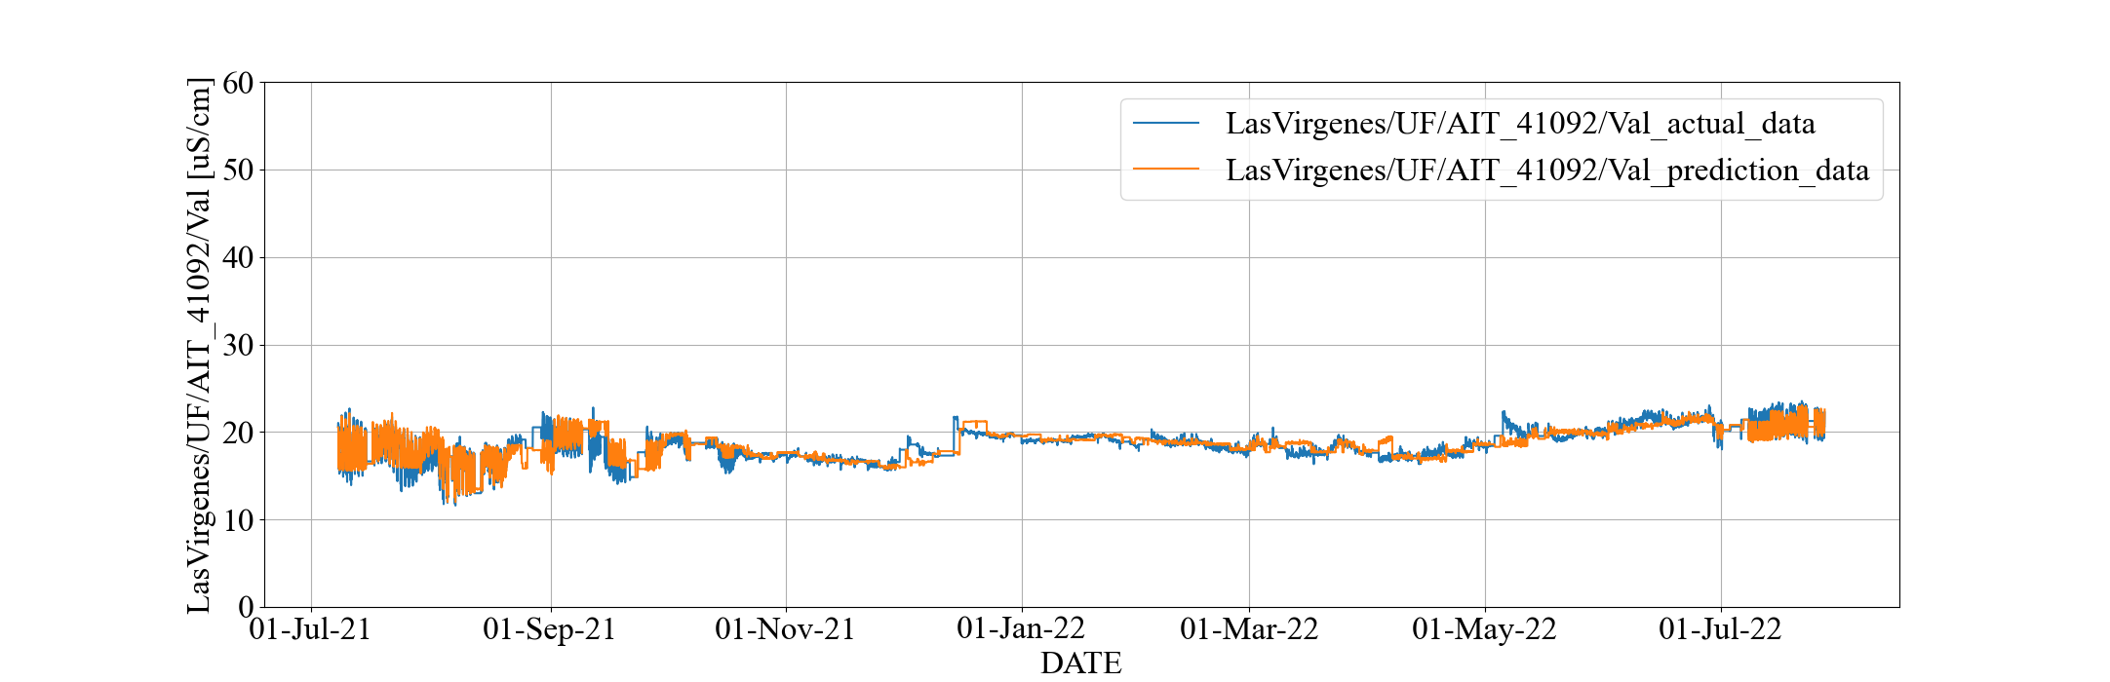

**(a) 1st Stage Permeate Conductivity**

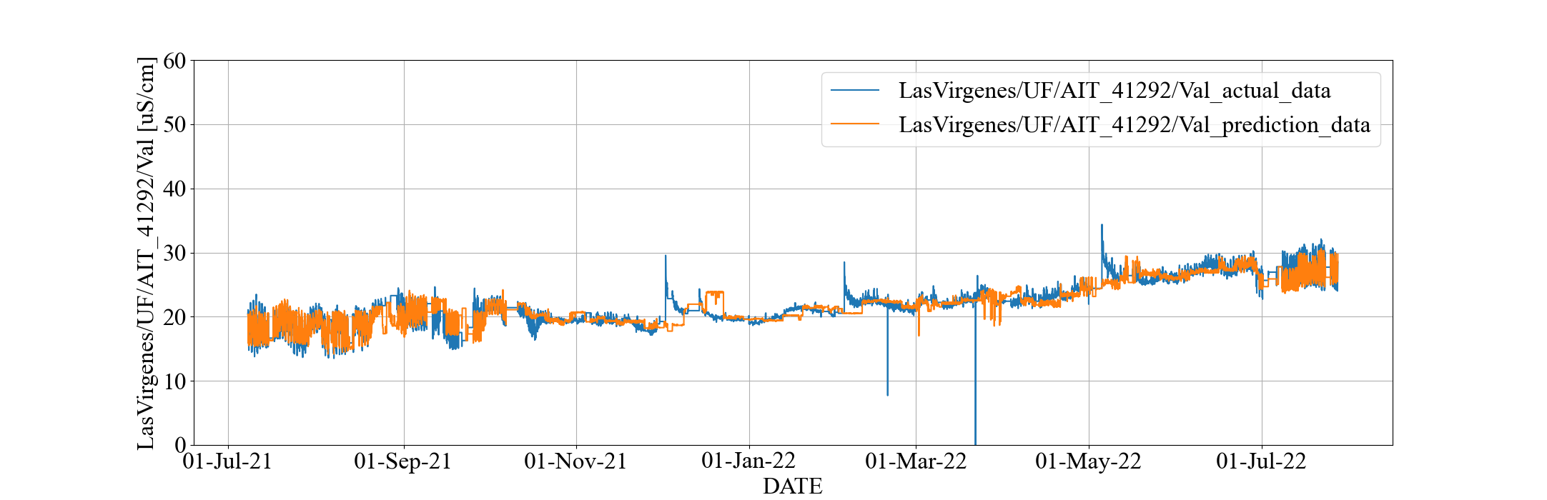

**(b) 2nd Stage Permeate Conductivity**

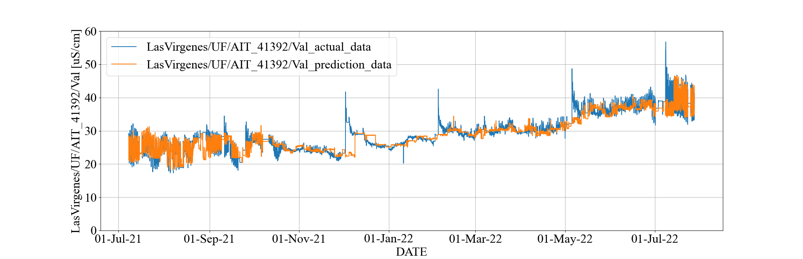

**(c) 3rd Stage Permeate Conductivity**

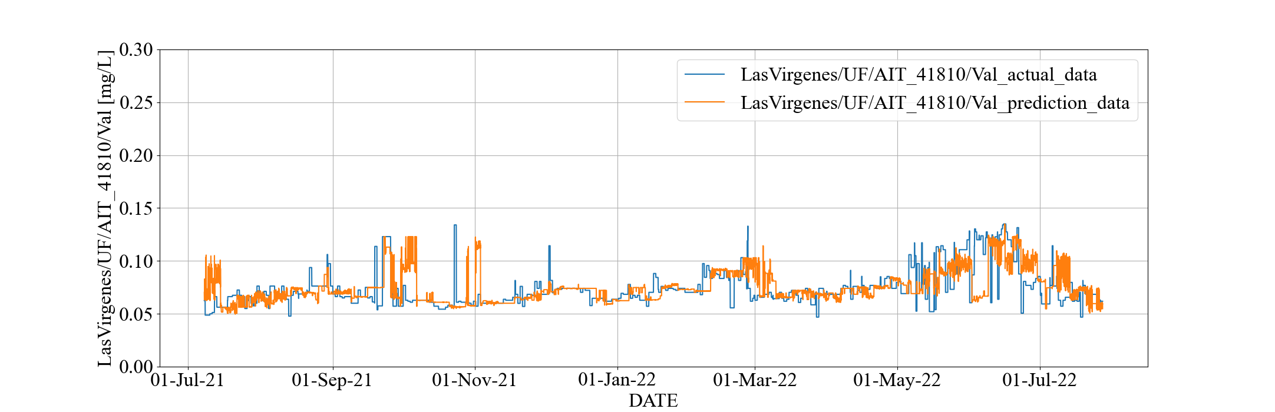

**(d) Permeate TOC**

**Figure 2.2.3: Prediction Trend in All Period with RF (LVMWD)**



**(a) Prediction Trend of 1st Stage Permeate Conductivity with MLR**



**(b) Prediction Trend of 1st Stage Permeate Conductivity with RF**

**Figure 2.2.4: Comparison of Prediction Trends by MLR and RF (LVMWD)**

**2.3. RO Membrane Fouling Estimation Model**

In the optimization of chlorine dosage forming chloramine, fouling progress and prevention effect should be considered. We observed a significant increase of 3rd stage feed pressure (while the permeate flow rate was constant) in a period while the total chlorine was low. We assumed that fouling affects the permeability of membrane and analyzed the relation between total chlorine and feed pressure increase. However, biofouling usually happened lead position in membrane system (meaning 1st stage in this case) and differential pressure (dP) increase is seen and subsequently feed pressure increase. Therefore, we also tried to analyze operating data comparison among membrane system and chemical projection. As a result, we found there were several findings and the points which should be improved in terms of membrane operations. Main findings are following two points.

1. The system might have also scale generation in 3rd stage.

3rd stage feed pressure was irregularly increase in period-4, 5, Figure 2.3.6 defines the period 1 to 5, in which total chlorine was less than usual, especially in period-4, and this might lead biofouling. However, we could not find dP increase during these periods. As mentioned above, usually biofouling is seen at lead position in the system as dP increase before feed pressure increase.

Fig 2.3.1 shows feed pressure, normalized flow and dP which are useful to distinguish which phenomenon happened between biofouling or scaling. There are no dP increase and even decreasing during period-4. The dP decreasing might be due to less feed flow in 3rd stage and this also leads higher scale potential.

Considering scale generation, we tried to have membrane system and chemical dosing projection by using the software provided from each component suppliers with actual water quality information. Through the projection study, we found anti-scalant, which was used in the plant, can handle such water quality with 85% recovery and actual operated condition, if anti-scalant was appropriately dosed and water quality does not have significant change.

1. Free chlorine was detected in some periods and leads to permeate water quality degrading due to membrane salt rejection performance degrading.

Fig. 2.3.2 shows Free chlorine, EC (Feed / Permeate) trend, salt passage (Normalized SP) in 1st /3rd stage and RO feed ORP. Generally free chlorine deteriorates polyamide chemical structure which work for salt rejection. Subsequently permeate water quality is degraded (seen in Permeate EC increase). Additionally existing transition metal ions such as iron and manganese, accelerate membrane degrading because of catalytic effect.

Permeate EC increase (Normalized SP increase) is due to free-chlorine which should be maintained undetectable level. ORP meter is usually used to avoid inflow of free chlorine. Especially applying chloramine need to be special care about free chlorine control.

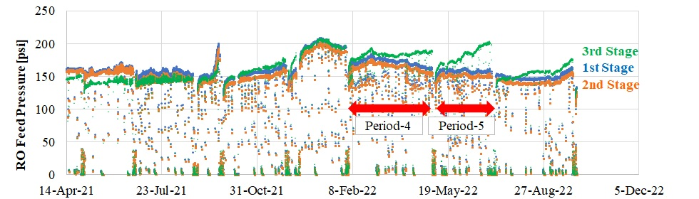

1. **RO Feed Pressure**

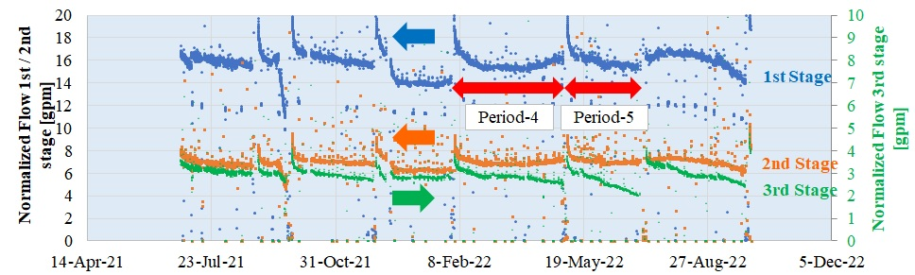

**(b) Normalized Flow**

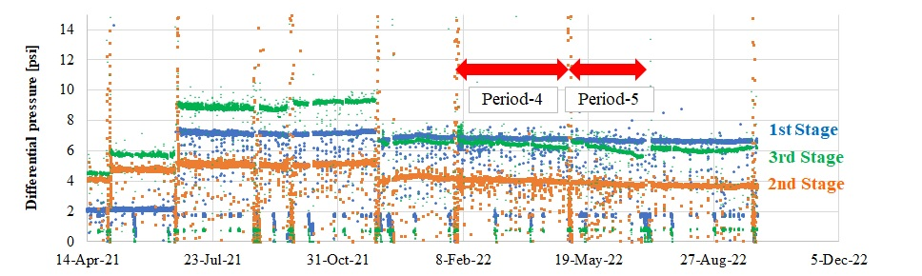

**(c) Differential Pressure**

**Figure 2.3.1: RO Feed Pressure, Normalization Flow, Differential Pressure**

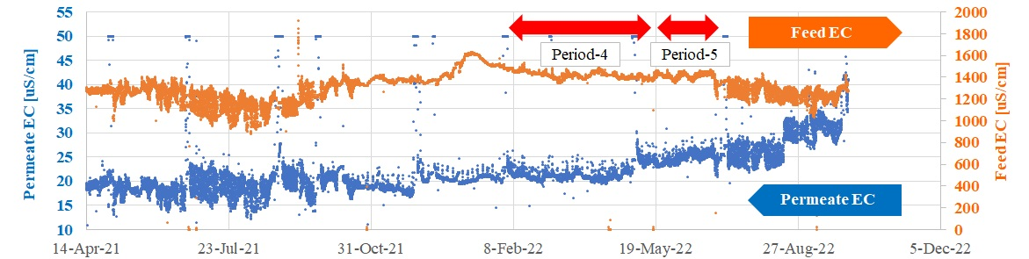

1. **RO Permeate / Feed EC**

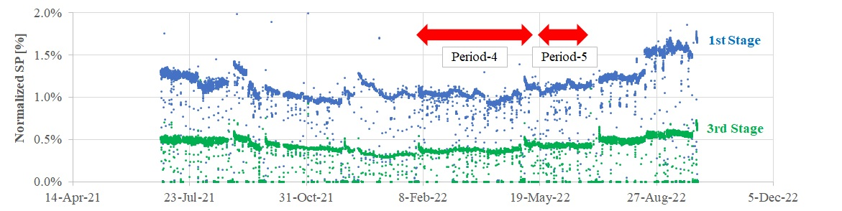

1. **Normalized SP (Salt Passage)**

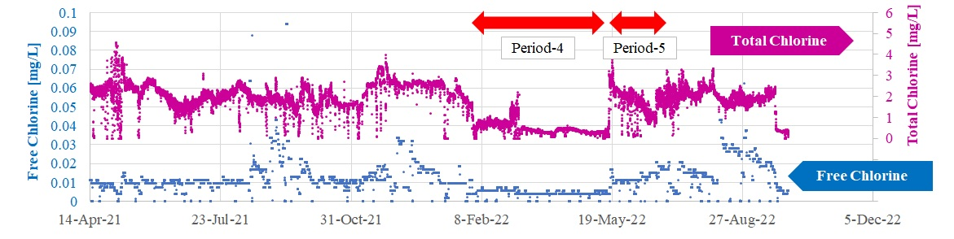

1. **Free / Total Chlorine**

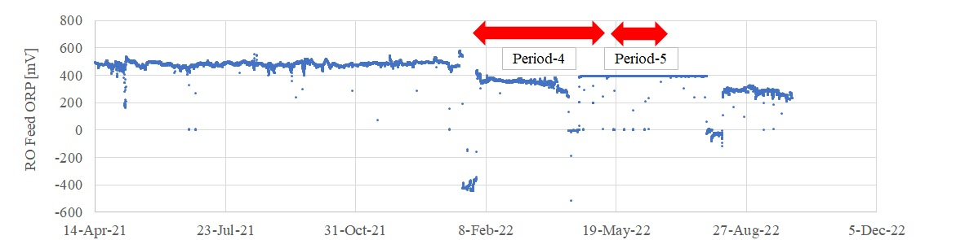

1. **RO Feed ORP**

**Figure 2.3.2: Permeate/Feed EC, Normalized SP (1st / 3rd stage),   
Free/Total Chlorine, Feed ORP**

**2.3.1. Method of Analysis on Total Chlorine and Membrane Performance**

Figure 2.3.3 (a) shows that the operation of LVMWD maintains the recovery rate of treated water. Recovery rate is calculated from feed and permeate flow rates. Figure 2.3.3 (b) and (c) show the trends of the feed and permeate flow rates. The trends show that the permeate flow rate is almost constant. If the performance of the membrane degrades and other conditions are the same, the permeate flow rate decreases. In order to maintain the permeate flow rate under such conditions, the feed pressure must be increased.

Figure 2.3.4 shows the 1st, 2nd, and 3rd stage feed pressure trends. The periods marked by red bars indicate the dates and times when CIPs took place. We focused on the July 2021 to August 2021 and October 2021 to June 2022 for the analysis. We excluded the other periods because the RO system was operated in very different conditions; the modules were in 2-stage configuration, the membranes were replaced periodically, the operational data contained abnormal values, or there were operational problems.

Figure 2.3.5 shows that the feed pressures of all three stages have similar and correlated trends. However, the 3rd stage feed pressure value increased around April 2022, which is indicated by a dashed red circle in the figure.

The RO system has two pumps, which are located at the 1st stage feed and the 3rd stage feed, which means that those pressures could be controlled independently. The trend of the 3rd stage feed pressure deviates from those of 1st and 2nd stages around April 2022. This means that the booster pump before the 3rd stage had higher load than expected, which may indicate that the relative degrading speed of the performance of 3rd stage to the 1st and 2nd stages was higher than usual.

To compensate the difference of operating conditions among time periods, we plotted the ratio of the 3rd feed pressure to the 1st one in Figure 2.3.5. In other words, we normalized the performance of the 3rd stage with respect to the 1st stage. The steady slope was observed before April 2022, but the slope became steep suddenly in April.



**(a) Recovery Rate**



**(b) Feed Flow Rate**



**(c) Permeate Flow Rate**

**Figure 2.3.3: Recovery Rate and Flow Rate Trends (LVMWD)**



**Figure 2.3.5: Feed Pressure Ratio (LVMWD)**



**Figure 2.3.4: Feed Pressure Trends (LVMWD)**

* + 1. **Result of the Analysis on Total Chlorine and Membrane Performance**

Next, we tried to correlate the change of the 3rd-to-1st feed pressure ratio with the change of total chlorine. If we could create a quantitative model between the amount of total chlorine and the speed of performance degradation, we could optimize the total chlorine while keeping the performance.

Figure 2.3.6 shows the trend of total chlorine. The period marked with the dashed red circle shows that the amount of total chlorine is about 0.5 mg/L, which is lower than that of total chlorine in other periods. The period coincides with the time when the slope in Figure 2.3.5 began to steepen. A possible interpretation is that chloramine was exhausted at the 1st and 2nd stages, which caused biofouling at the 3rd stage, and CIPs removed scaling but was not enough to stop biological growth.

In this analysis, the periods between each CIP are named “Period 1”, “Period 2”, ..., “Period 5” in chronological order as indicated in Figure 2.3.6. Figure 2.3.7 is a scatter plot of total chlorine and feed pressure ratios, where the period number is coded by the color. Figure 2.3.7 (a) plots 30-minute averages and (b) plot 1-day averages. The feed pressure ratio and the total chlorine shows no strong relationship (the correlation coefficients are approximately $-0.28$ in both plots).

Figure 2.3.8 shows a scatter plot of the daily sum of the total chlorine and the daily increment of the feed pressure ratio, where the correlation coefficient was about $-0.10$. The correlation is weak, and we cannot conclude the performance degradation is explained by the total chlorine. We will continue to investigate.

Furthermore, because clear relationship between the performance degradation and total chlorine is not observed, it is possible that the cause of the performance degradation is scaling of minerals. We recommend a study in that direction by measuring the ion concentration in the feed water and calculating the potential for precipitation.



**Figure 2.3.6: Total Chlorine (LVMWD)**

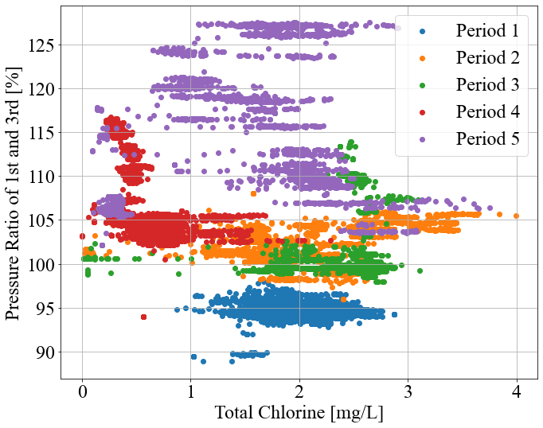 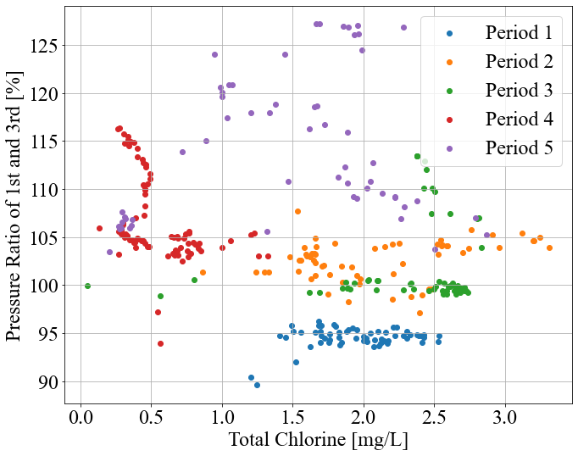

**(a) 30 minutes data (b) 1 day data**

**Figure 2.3.7: Correlation between Total Chlorine and Pressure Ratio (LVMWD)**

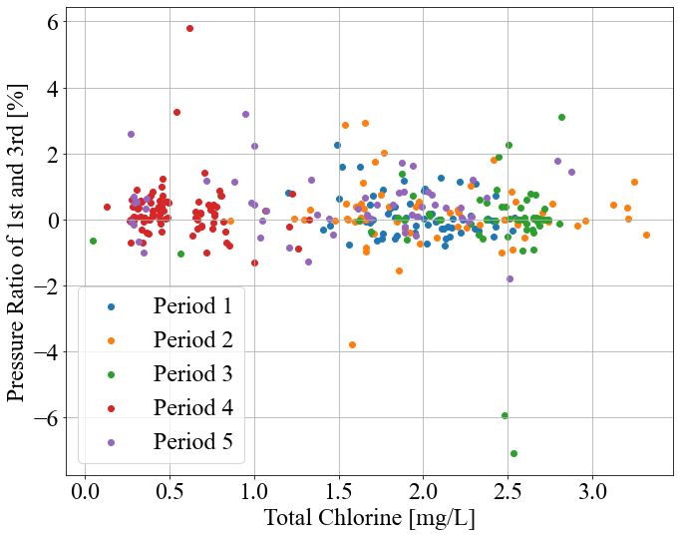

**Figure 2.3.8: Correlation between Total Chlorine and difference of Pressure Ratio from previous time value (LVMWD)**

* 1. **RO Optimization Calculation**
     1. **Optimization Problem for RO Operational Scheduling**

We formulated RO optimization problem as in the case of OCWD. The objective function is sum of the UF filtrate total chlorine during the optimization period. The constraint conditions are given by lower and upper limit, and water quality standards limit based on Logarithmic Reduction Value (LRV). Table 2.4.1 shows only the major constraints. The detail of the problem formulation is provided as “Additional Materials A2” at the end of this report.

* + 1. **RO Optimization Module**

We used the RO optimization module and solved the above constrained optimization problem same as in the case of OCWD.

**Table 2.4.1: Major Constraints (upper/lower limit and LRV)**

|  |  |  |  |
| --- | --- | --- | --- |
| **Description** | **Units** | **Lower** | **Upper** |
| Stage 1 Permeate EC | $$μS/cm$$ | 0 | 50 |
| Stage 2 Permeate EC | $$μS/cm$$ | 0 | 50 |
| Stage 3 Permeate EC | $$μS/cm$$ | 0 | 60 |
| Combined Permeate EC | $$μS/cm$$ | 0 | 60 |
| Combined Permeate TOC | mg/L | 0 | 0.15 |
| Combined Permeate EC LRV | - | 1.7 | 2.5 |
| Combined Permeate TOC LRV | - | 1.8 | 2.5 |

* + 1. **Optimization Results**

This part shows the optimization results. The method trains one week's data and optimizes the following week. The training and optimization periods are shifted sequentially and the entire of the consolidated optimization period is from March 14th to April 17th, 2022, i.e., 5 weeks in this report.

The prediction results by the RO optimization module are shown in Figures 2.4.2 and 2.4.3. Figure 2.4.2 is prediction trend of permeate combined TOC and LRV of that, and Figure 2.4.3 is prediction trend of permeate combined conductivity (EC) and LRV of that. From these figures, permeate EC prediction performance is good while permeate TOC prediction performance deteriorates in the 4th and 5th weeks.

This result is due to the influence of external factors. Figure 2.4.4 is the RO feed pressure trend chart and Figure 2.4.5 is the scatter chart between UF total chlorine and combined permeate TOC in the optimization period. In Figure 2.4.5, the color of the marker means the actual data for each week. Figure 2.4.4 shows RO feed pressure is significantly declining in the 3rd and 4th weeks and the tendency between training and optimization period is different. And Figure 2.4.5 shows the coefficient of determination $R^{2}$ between total chlorine and permeate TOC is 0.14, i.e., they are basically weakly related. Therefore, the TOC prediction performance deteriorates significantly.

The optimization results are shown in Figures 2.4.6, 2.4.7, and 2.4.8. Figure 2.4.6 is optimized trend of chemical dosage, i.e., UF total chlorine, Figure 2.4.7 is optimized trend of permeate combined TOC and LRV of that, and Figure 2.4.8 is optimized trend of permeate EC and LRV of that. From these figures, the optimal values of EC and TOC are almost the same as the predicted values while the optimal value of total chlorine is lower than the actual value in the 4th and 5th week. The results shows that water quality is highly dependent on disturbance variables, i.e., temperature or RO feed pressure, but not nearly as dependent on total chlorine in this case. To improve the relationship, it needs to introduce the RO membrane fouling model to the optimization model and use stably measured online data.

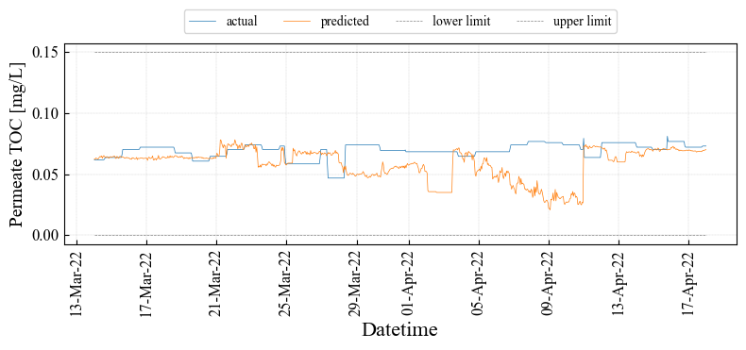

1. **Permeate Combined TOC**

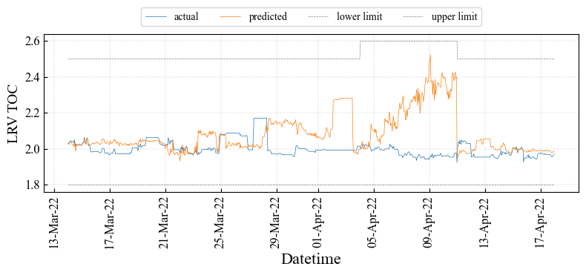

1. **LRV of Permeate Combined TOC**

**Figure 2.4.2: Prediction Results of TOC using RO module (LVMWD)**

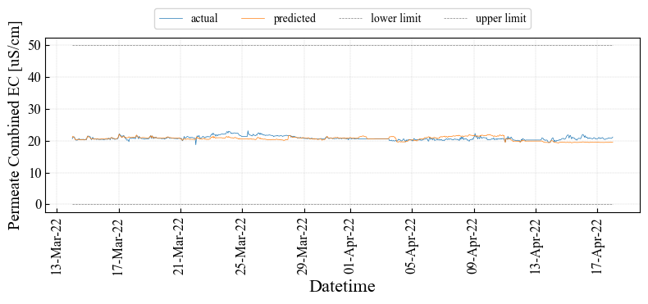

1. **Permeate Combined EC**

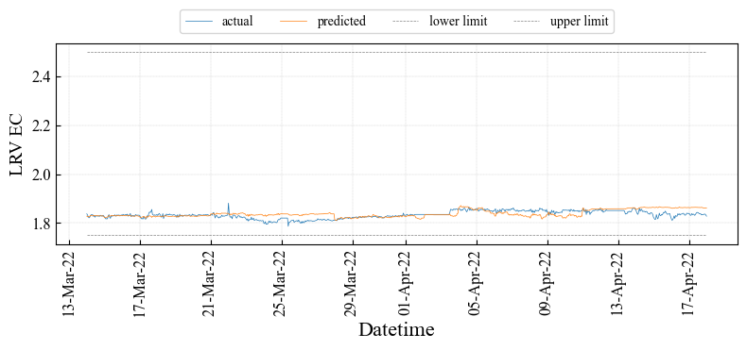

1. **LRV of Permeate Combined EC**

**Figure 2.4.3: Prediction Results of EC using RO module (LVMWD)**



**Figure 2.4.5: Scatter Chart between UF Total Chlorine and Permeate TOC (LVMWD)**

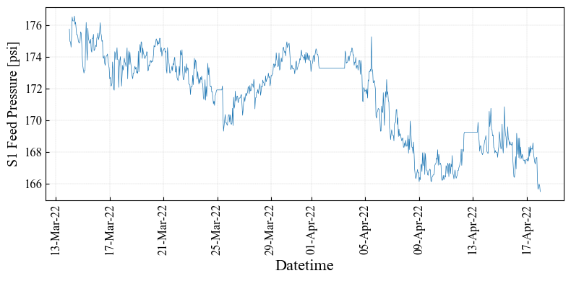

**Figure 2.4.4: RO Feed Pressure Trend Chart in Optimization Period (LVMWD)**

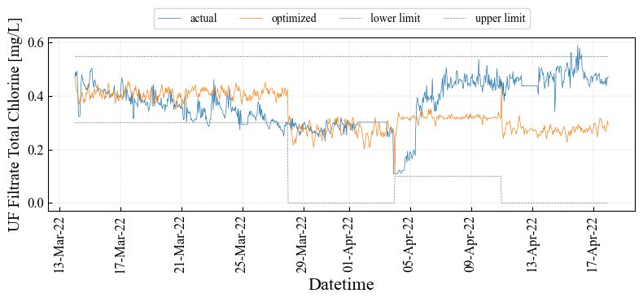

**Figure 2.4.6: Optimization Results of UF Total Chlorine using RO module (LVMWD)**

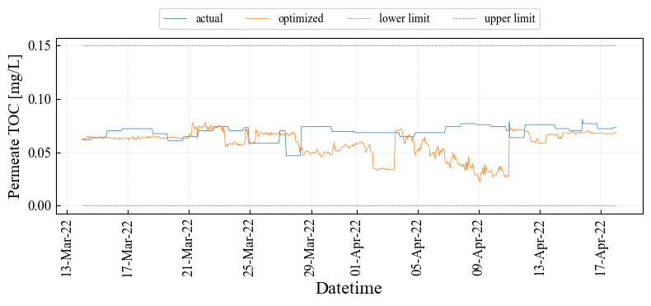

1. **Permeate Combined TOC**

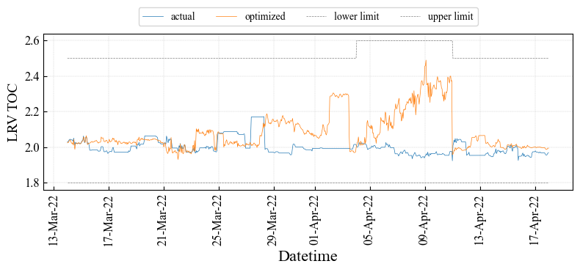

1. **LRV of Permeate Combined TOC**

**Figure 2.4.7: Optimization Results of TOC using RO module (LVMWD)**

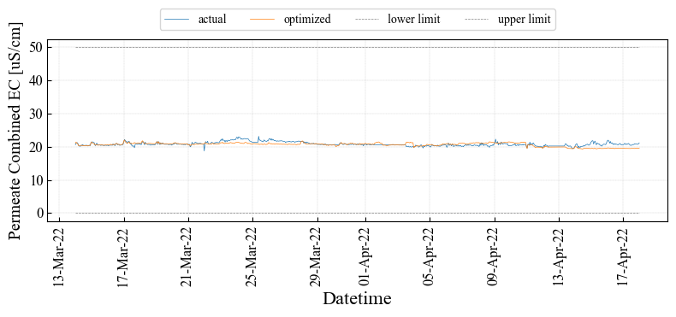

1. **Permeate Combined EC**

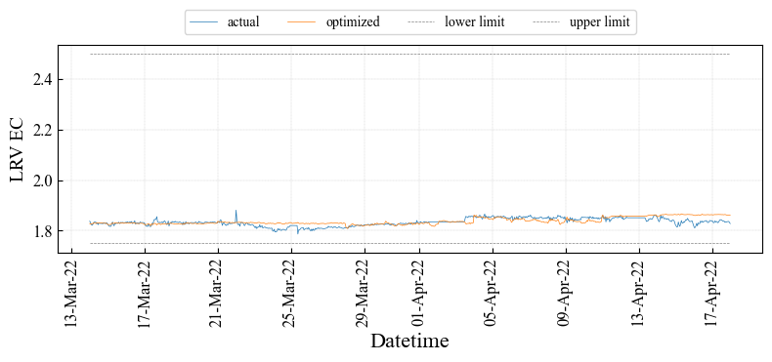

1. **LRV of Permeate Combined EC**

**Figure 2.4.8: Optimization Results of EC using RO Module (LVMWD)**

* + 1. **Optimization Effects**

The optimization effect shows Table 2.4.2. We do not have information on the chemical cost that 1 mg/L of total chlorine is equivalent to, so we assumed it to be $100/(mg/L) per 1 hour, which is a placeholder value and does not reflect any actual cost. Using this number, the reduction cost is about $85.6 per day i.e., $0.03M per year by optimization. Even though the RO optimization module works correctly, there is room for improvement in the optimization model including the prediction model. To improve the relationship, it needs to introduce the RO membrane fouling model to the optimization model and use stably measured online data as discussed in the previous section.

**Table 2.4.2: Optimization Effect (LVMWD)**

|  |  |  |  |  |  |  |
| --- | --- | --- | --- | --- | --- | --- |
| **Description** | **Units** | **Actual** | **Optimized** | **Diff**  **(Opt-Act)** | **Diff – Err.** | **Cost**  **[$/day]** |
| Total Chlorine | mg/L | 0.37 | 0.34 | $-$ 0.04 | $-$ 0.04 | $-$ 85.6 |
| EC | $$μS/cm$$ | 20.8 | 20.6 | $-$ 0.19 | $+$ 0.02 |  |
| TOC | ppm | 0.069 | 0.058 | $-$ 0.011 | $-$ 0.000 |  |
| LRV EC | - | 1.83 | 1.84 | $+$ 0.004 | $-$ 0.000 |  |
| LRV TOC | - | 2.00 | 2.08 | $+$ 0.09 | 0.001 |  |

* 1. **Future Tasks**

The optimization result represented in this report considers only the water quality model. The optimization variables, which are the ones we can manipulate, are assumed to be the total chlorine. However, it affects mainly on the progress of fouling in a long term, and they do not have strong effects on the water quality in a short term. For this reason, no or little cost improvement is found in the optimization with only water quality model. We need to integrate fouling model into the optimization to consider the longer effects of total chlorine on the membrane performance.

In fact, LVMWD implemented 2-stage and 3-stage operations were mixed, and even during the 3-stage operation, the number of RO elements changes 6 and 7, which making it difficult data set to monitor steady-state operation. In addition, since the operational conditions were not suitable for developing machine learning or AI control, it was necessary to provide a period of about six months during the steady status in which only the total chlorine concentration was varied to learn the response of RO system. We would like to separately present the recommended conditions for online demonstration in Year 2.

In order to optimize chemical dosage while considering fouling, we need to model the relationship between them as discussed in Section 2.3. However, insufficient data sets are available to learn UF total chlorine and pressure increase for AI optimization. It is difficult to analyze the pressure increases, CIP events, and their causal relationship with total chlorine and other water qualities, because operational conditions were intentionally changed after each CIP and only 5 time periods are available for analysis. From the machine learning perspective, there are not enough samples for many changed factors. We recommend performing experiments to collect much data with fewer changing factors: longer CIP intervals with only changing total chlorine (for example, starting with 2.0 [mg/L] of total chlorine and reducing it stepwise over 4000 hours).

There is a possibility that scaling is also problematic in LVMWD. If ion concentration in the feed water could be measured, the potential for mineral precipitation could be evaluated.

1. **Desktop Analysis based on WBMWD**

We received three years of operational data in West Basin Municipal Water District (WBMWD) and analyzed the data focusing on the cost reduction at Title 22 filter. WBMWD process flow schematic is shown in Figure 1‑1. WBMWD receives secondary effluent from the City of Los Angeles’s Hyperion Water Reclamation Plant (HWRP)[10]. The secondary effluent from HWRP is distributed to the two streams: a. 40 MGD for industrial and irrigation, and another b. 45 MGD for cooling tower and boiler feed as shown in Figure 1‑1.

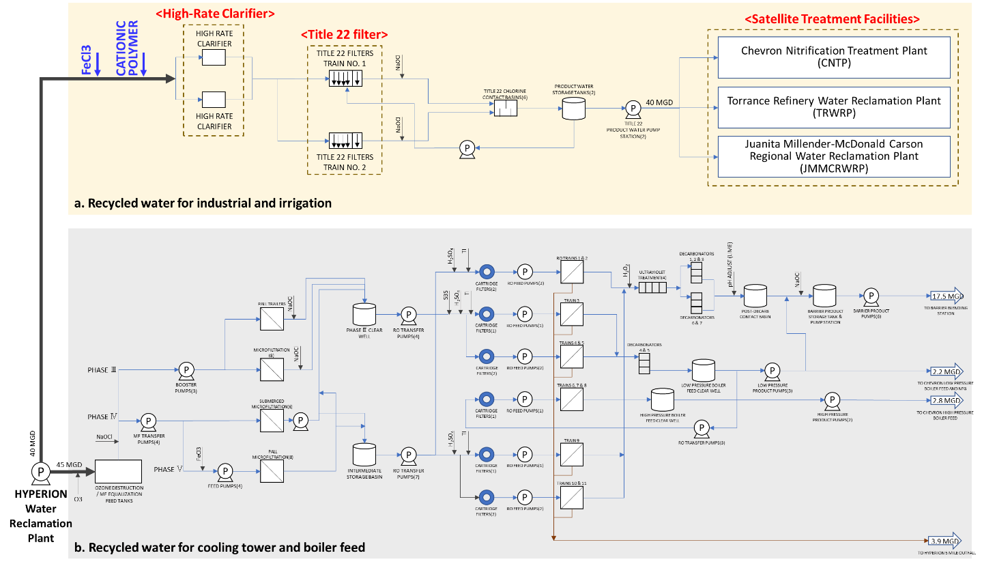

Figure 1‑1 WBMWD Process Flow Schematic

The objective of data analysis is to maintain effluent turbidity from the Title 22 filter less than 2 NTU required by the Title 22 criteria[11] and to optimize FeCl3 (ferric chloride) and cationic polymer injected before the High-Rate Clarifier (HRC) for cost saving.

To analyze data for the Title 22 filter, both online data measured hourly (Hourly), and grab sampling data measured daily (Daily) listed in Table 1‑1 were provided. The data listed from “1” to “12” were retrieved hourly from January 2020 through March 2023, and from “G1” to “G3” were grabbed from September 2020 through March 2023. The measurement data are listed in Table 1‑1 and the measurement points in the process flow diagram illustrated in Figure 1‑2.

Table 1‑1 Data List

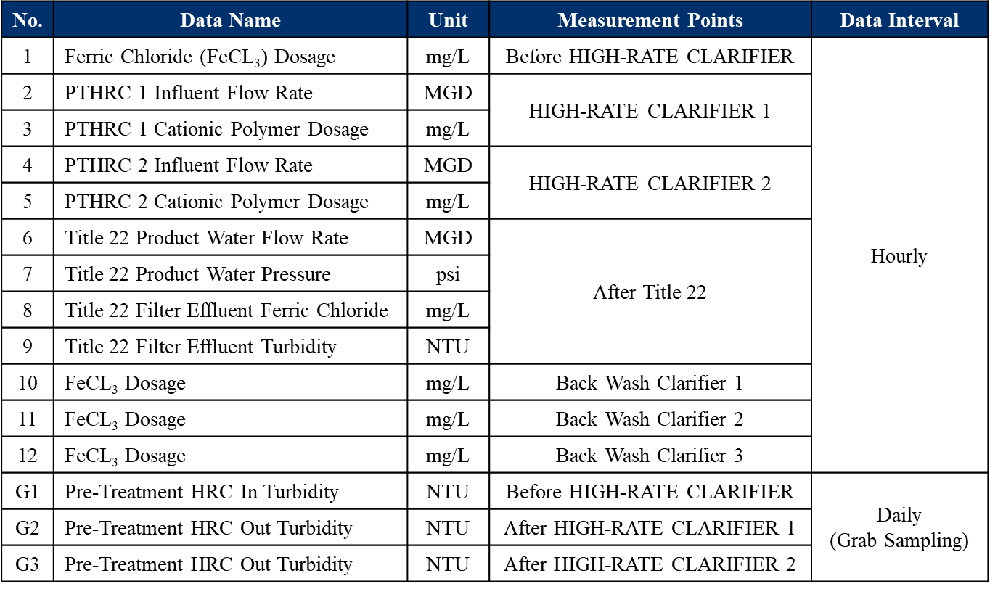

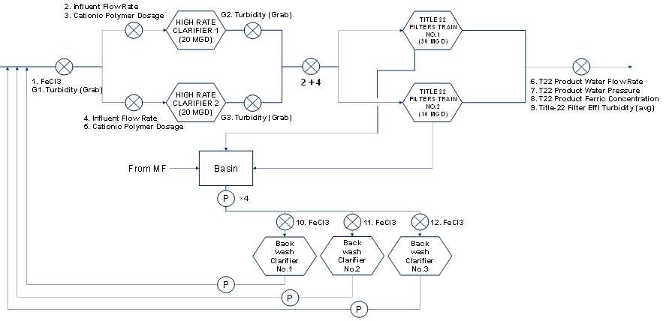

Figure 1‑2 Measurement Points in Process Flow Diagram

To achieve the objective using those data, we created a model by Data-Driven Modeling for Optimization (DDMO) developed by Yokogawa Electric Corporation.

We explain the DDMO algorithm and report the optimization results in more detail.

* 1. **Model Creation by DDMO**

In this data analysis, we created models by DDMO.

DDMO is a modeling technology that can extensively extract all characteristics of process variables from historical operation data of actual plants[12]. It is possible to improve the operation of customers’ plants with this technology that can create models elucidating relationships among energy consumption, operation cost and product quality, and derive optimum operation conditions of plants.

Characteristics are extracted by principal component analysis (PCA) as equations[13]. PCA is a popular technique for analyzing large datasets and is a statistical technique for reducing the dimensionality of a dataset. It is used for making predictive models.

As shown in Figure 1‑3, PCA finds the best planes to express the data. And some equations are derived as a result of data analysis by PCA. Equation 3-1 is an example of equations.

$$\begin{aligned}c_{1}x_{1}+c_{2}x_{2}+c_{3}x_{3}+c_{4}x_{4}=0\#\left(3-1\right)\end{aligned}$$

$x_{i}$ ($i=1,2,3,4$) are variables such as chemicals, water qualities and so on, and coefficient values $c_{1}=0.31,c_{2}=-0.15,c_{3}=0.13, c_{4}=0.46$ are calculated by PCA. Using equations, optimal values such as chemicals are derived that satisfy the constraints such as water quality regulations.

Since these calculations can be executed automatically, the coefficient values of characteristic equations can be adjusted without the manual tuning to improve the accuracy of calculating.

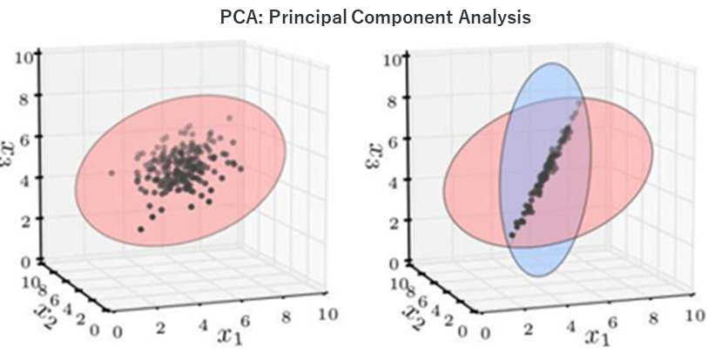

Figure 1‑3 Extraction of Equations by PCA

* 1. **Models**

In this data analysis, we created two types of models of an hourly average and a daily average model by DDMO.

The objective of the model creation is to optimize ferric chloride and cationic polymer dosages injected before the HRT while maintaining Title 22 filter effluent turbidity as required by the Title 22 criteria.

In this section, we report the model creation and the optimization results.

### Hourly Average Model

An hourly average model is the model created using hourly data listed in Table 1‑1.

Ideally, the chemical dosages should be controlled considering the fluctuation of influent water quality such as turbidity. However, turbidity is only measured online at effluent of the Title 22 filter, not measured online at the Title 22 filter feed. Therefore, we created the hourly average model with limited datasets.

#### Calculation Status

We created the model and optimized ferric chloride and cationic polymer dosages under those prepositions.

* Variables

The variables to optimize ferric chloride and cationic polymer dosages are listed in Table 1‑2. While the data “a” through “e” are classified as explanatory variables, the data “f” and “g” are classified as objective variables. All of them are given by online hourly average data.

In the model, influent flow rates were given by “b” and “c” and total amount of cationic polymer dosage were calculated from “d” and “e”, respectively.

Table 1‑2 Variables for Hourly Average Model

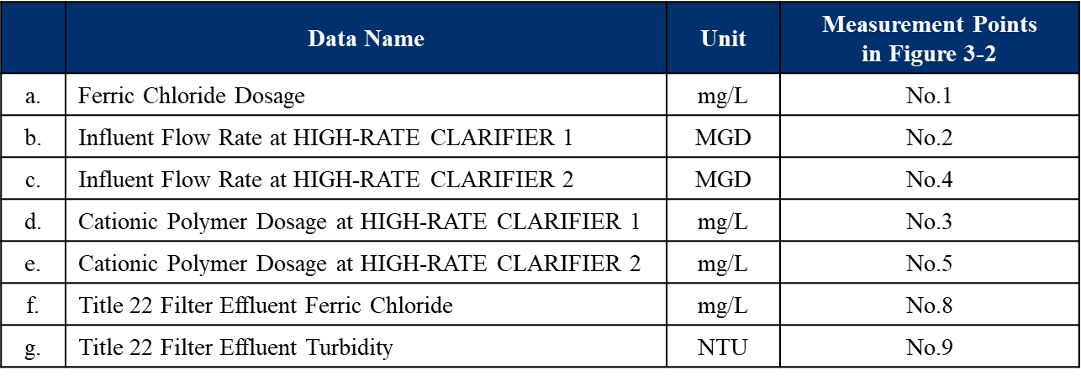

* Learning Period and Evaluation Period

Figure 1‑4 shows the turbidity behavior of Title 22 filter effluent turbidity from April 2021 to March 2023. The period boxed in blue is the learning period from 21st to 28th November in 2021, and the period in red is the evaluation period from 29th November to 5th December in 2021.

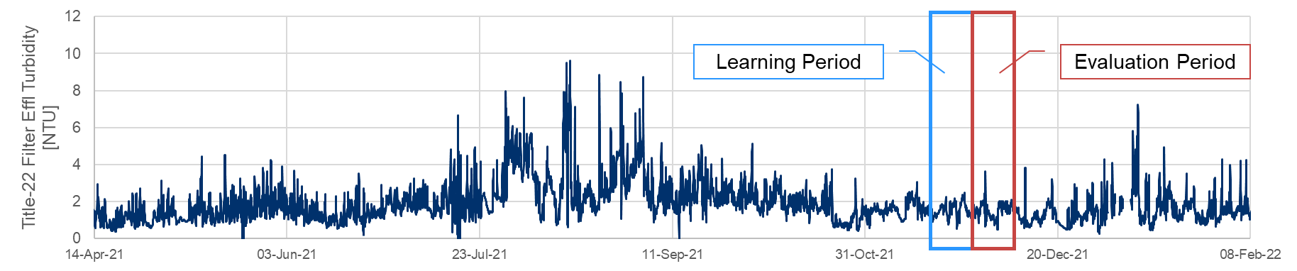

Figure 1‑4 Learning Period and Evaluation Period for Hourly Average Model

The learning period was selected that the correlation between ferric chloride and Title 22 filter effluent turbidity was negative at -0.52. Figure 3-5 shows the scatter plot of ferric chloride dosage (data “a” in Table 1‑2) and Title 22 filter effluent turbidity (data “g” in Table 1‑2).

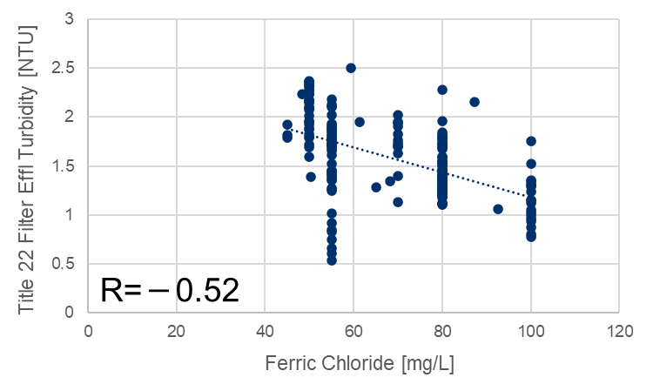

Figure 1‑5 Correlation between Ferric Chloride and Title 22 Filter Effluent Turbidity

#### Model Accuracy

Before the optimization calculation, we verified the model accuracy if the model created by DDMO can express the data correctly. The model accuracy was evaluated by root mean squared error (RMSE). This is calculated between actual data and predicted data in the prediction period and its mathematical definition is provided in “Additional Materials A4” at the appendix of this report.

The model accuracy was evaluated for objective variables, Title 22 filter effluent ferric chloride (data “f” in Table 1‑2) and Title 22 filter effluent turbidity, respectively. Figure 1‑6 and Figure 1‑7 show trend charts of Title 22 filter effluent ferric chloride, Title 22 filter effluent turbidity and RMSE of each. The actual and the calculated values are shown in yellow and blue lines.

Figure 1‑6 shows the actual value and the calculated value of Title 22 filter effluent ferric chloride. The model accuracy during the evaluation period was RMSE = 0.12. Figure 1‑7 shows the actual value and the calculated value of Title 22 filter effluent turbidity. The model accuracy during the evaluation period was 0.44 in RMSE. The model accuracy should be partially improved, but the overall trend was expressed well.

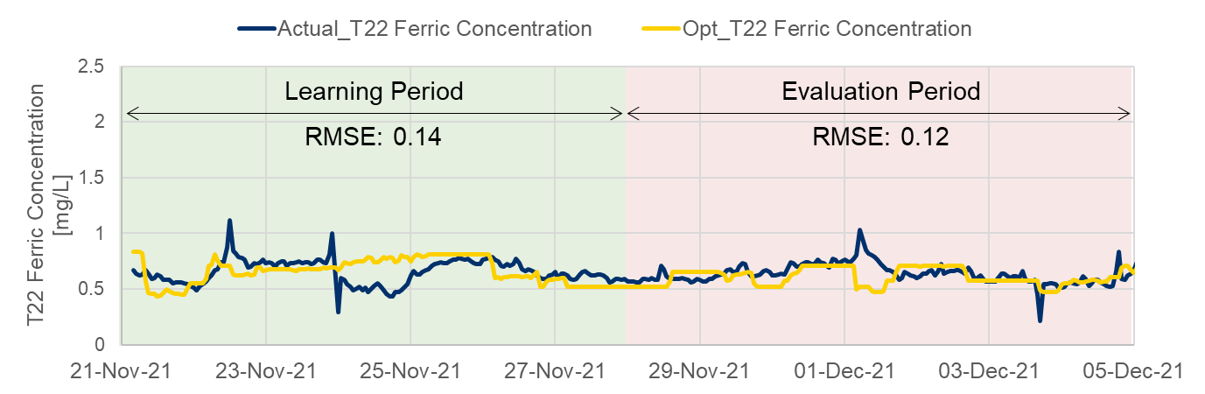

Figure 1‑6 Model Accuracy using Hourly Data (Title 22 filter effluent ferric chloride)

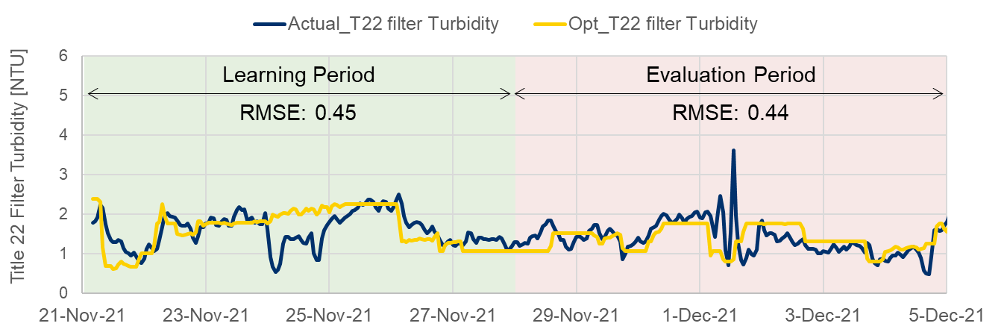

Figure 1‑7 Model Accuracy using Hourly Data (Title 22 Filter Effluent Turbidity)

#### Optimization Calculation

After verifying the model accuracy, the optimization calculation was executed to optimize ferric chloride and cationic polymer dosages.

In the optimization calculation, the influent flow rate was fixed to actual values because the influent flow rate derived from HWRF was uncontrollable. Therefore, ferric chloride and cationic polymer dosages were optimized to secure both Title 22 filter effluent ferric chloride and Title 22 filter effluent turbidity in accordance with change of the influent flow rate.

* Optimization Results

Figure 1‑8 (a) to (d) shows the optimization results, the blue line is actual values, and the red line is optimum values.

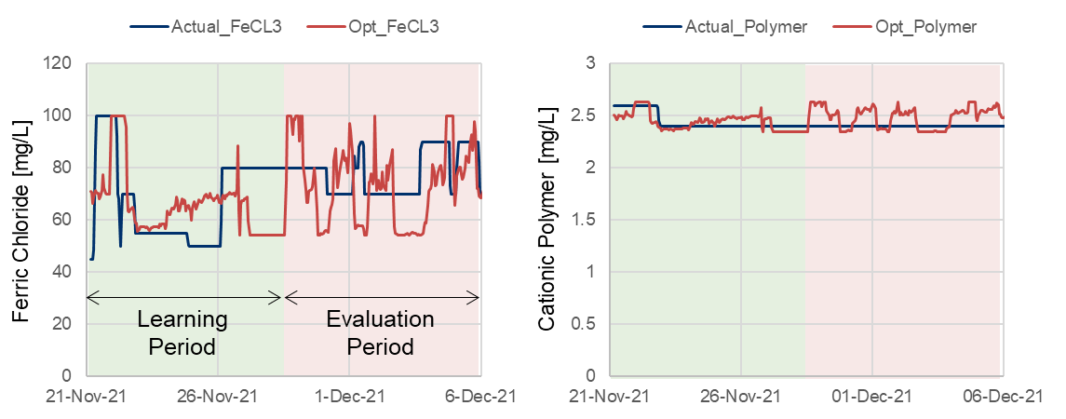

**(a) Ferric Chloride Dosage (b) Cationic Polymer Dosage**

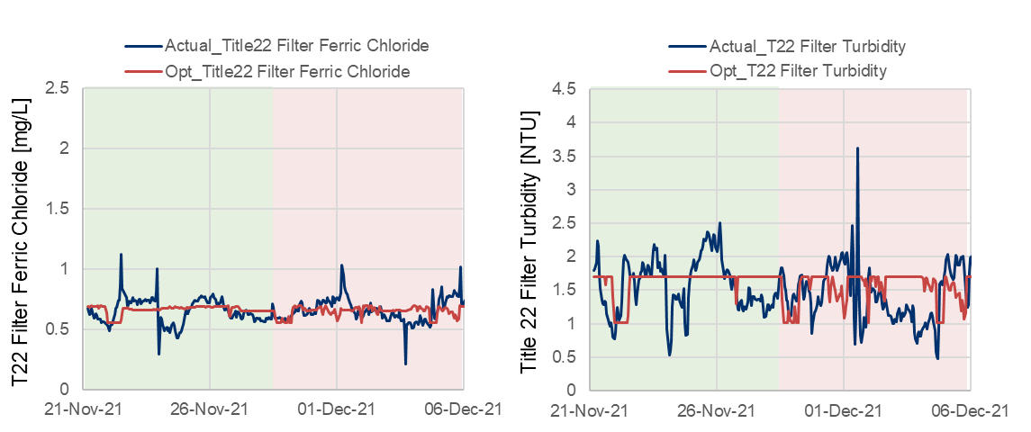

**(c) Title 22 Filter Effluent Ferric Chloride (d) Title 22 Filter Turbidity**

Figure 1‑8 Optimization Results

* Relationships between Actual Values and Optimum Values

We compared actual values with optimum values as a summary of the optimization calculation. Figure 3-9 (a) to (d) shows the comparison between actual values and optimum values during the evaluation period by bar graphs. The blue bars are the sum or the average of actual values, and the red bars are the sum or the average of optimum values.

As shown in (a) and (b), ferric chloride dosage was reduced by 6%, and cationic polymer dosage was increased by 3% as a result of the optimization calculation. Because the total amount of chemical dosage was reduced, Title 22 filter effluent turbidity raised by 4%.

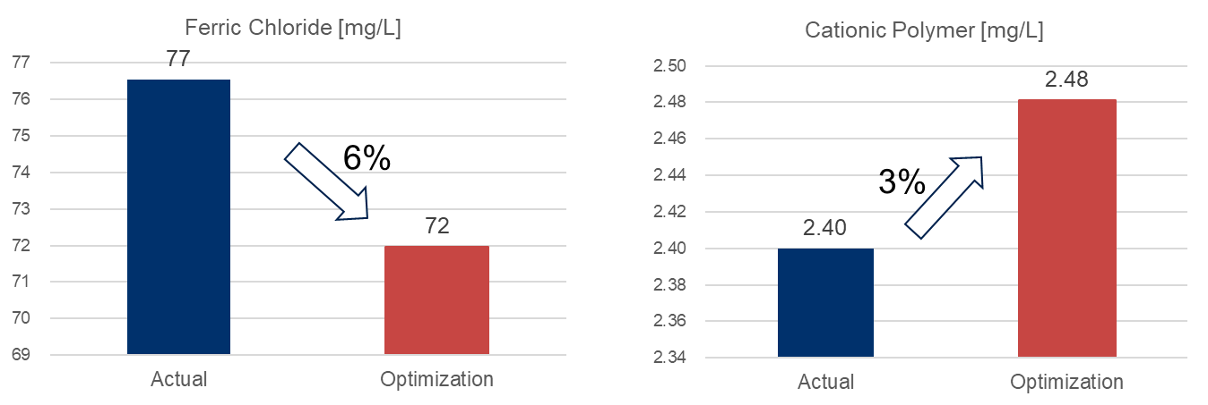

**(a) Ferric Chloride Dosage (b) Cationic Polymer Dosage**

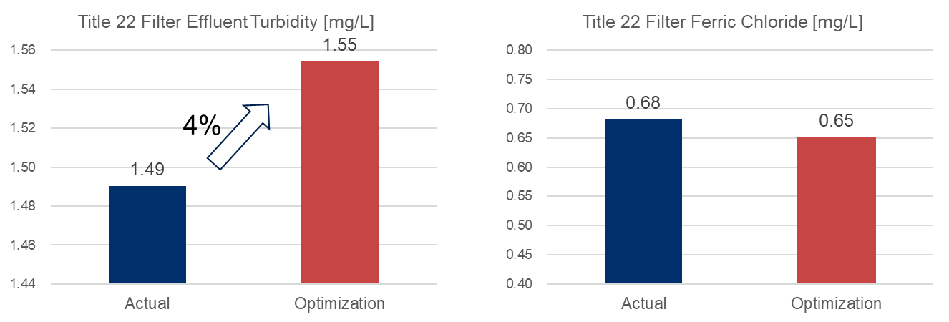

**(c) Title 22 Filter Effluent Turbidity (d) Title 22 Filter Effluent Ferric Chloride**

Figure 1‑9 Comparison between Actual Value and Optimum Value

### Daily Average Model

A daily average model is the model created using hourly and daily data listed in Table 1‑1. In this model, daily average data was given based on hourly measured data.

Ideally, the feed and effluent turbidity of the HRC should be measured online to control ferric chloride and cationic polymer dosages in accordance with the fluctuation of water qualities. However, the number of data for model creation was not sufficient due to the turbidity measured by grabbing. The daily average model was created with limited datasets as a reference.

#### Calculation Status

We created a model and optimized ferric chloride and cationic polymer under those prepositions.

* Variables

The variables to optimize ferric chloride and cationic polymer are listed in Table 1‑3. While the data “a” through “h” are classified as explanatory variables, the data “i” and “j” are classified as objective variables. All of them are daily average data.

In the model, influent flow rates were given by “b” and “c” and the total amount of cationic polymer dosage was calculated from “d” and “e”, respectively.

Table 1‑3 Variables for Daily Average Model

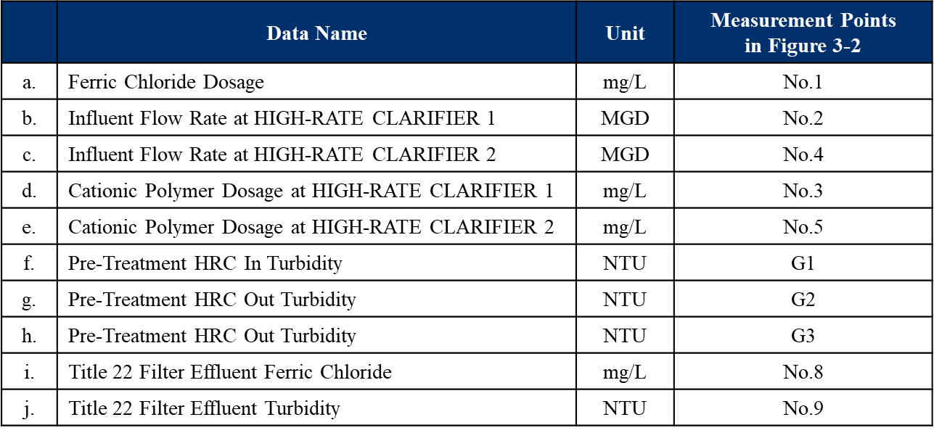

* Learning Period and Evaluation Period

Figure 1‑10 shows the behavior of Title 22 filter effluent turbidity from September 2020 to November 2022. The period boxed in blue is the learning period from 2nd February to 29th March 2022, and the period in red is the evaluation period from 6th to 20th April 2022.

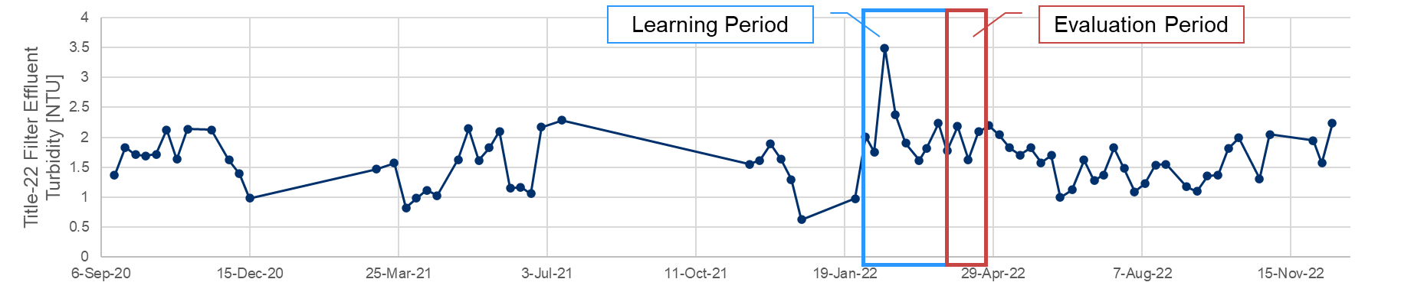

Figure 1‑10 Learning Period and Evaluation Period for Daily Average Model

Figure 1‑11 shows the scatter plot during the learning period. (a) is the scatter plot of ferric chloride (data “a” in Table 1‑3) and HRC effluent turbidity (average of the data “g” & “h” in Table 1‑3). (b) is the scatter plot of ferric chloride (data “a” in Table 1‑3) and Title 22 filter effluent turbidity (data “j” in Table 1‑3).

The learning period was selected that two statuses were considered.

* Correlation between ferric chloride and HRC effluent turbidity was negative at -0.51.
* Correlation between ferric chloride and Title 22 filter effluent turbidity was negative at -0.20.

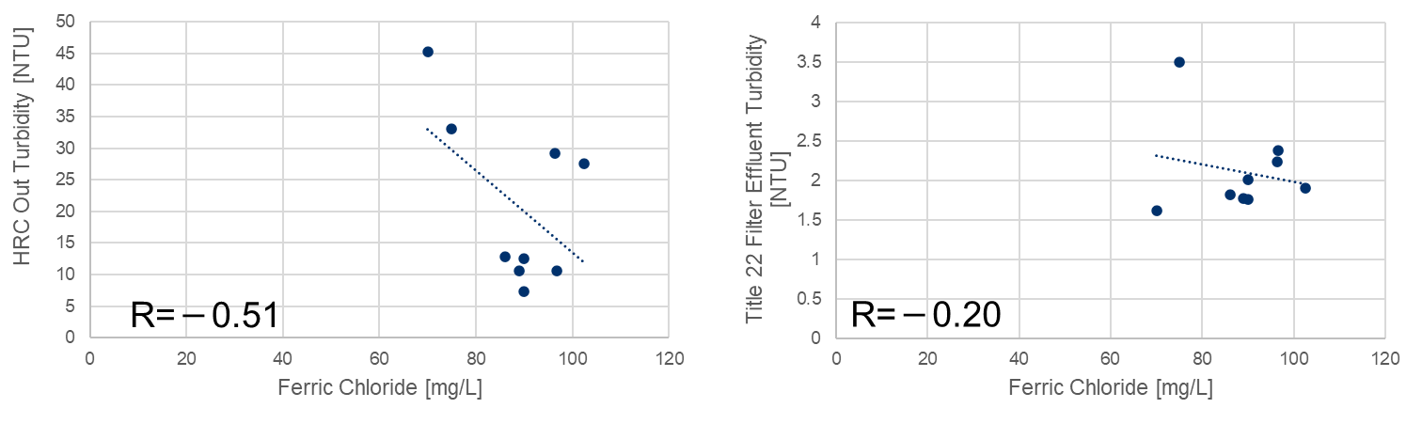

(a) Ferric Chloride vs. HRC Effluent Turbidity (b) Ferric Chloride vs. Title 22 Filter

Effluent Turbidity

Figure 1‑11 Correlation between Variables during the Learning Period

#### Model Accuracy

Before the optimization calculation, we verified the model accuracy if the model created by DDMO can express the data correctly. The model accuracy was evaluated by RMSE given by Equation 3-2.

The model accuracy was evaluated for objective variables, Title 22 filter effluent ferric chloride and Title 22 filter effluent turbidity, respectively. Figure 1‑12 (a) and Figure 1‑12 (b) show trend charts of Title 22 filter effluent ferric chloride, Title 22 filter effluent turbidity and RMSE of each. The actual and the calculated values are shown in yellow and blue lines.

Figure 1‑12 (a) shows the actual value and the calculated value of Title 22 filter effluent ferric chloride. The model accuracy during the evaluation period was 0.17 in RMSE. Figure 1‑12 (b) shows the actual value and the calculated value of Title 22 filter effluent turbidity. The model accuracy during the evaluation period was 0.65 in RMSE. Since the number of the data for the model creation was not sufficient, it is not possible to evaluate the model accuracy.

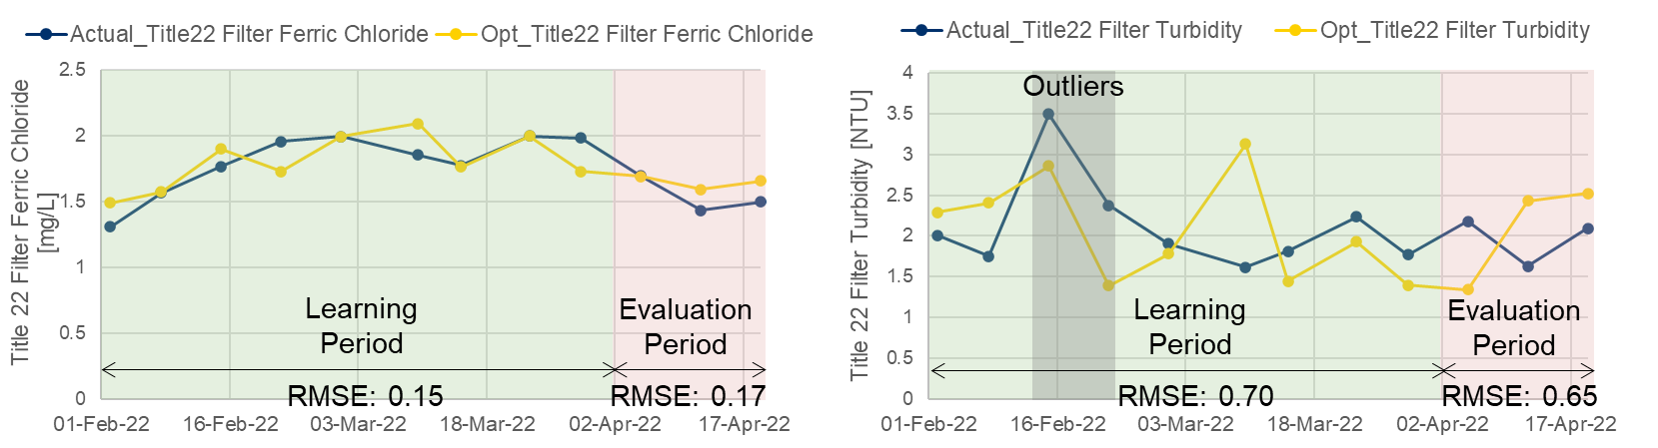

**(a) T22 Ferric Concentration (b) Title 22 Filter Effluent Turbidity**

Figure 1‑12 Model Accuracy using Daily Data

#### Optimization Calculation

After verifying the model accuracy, the optimization calculation was executed to optimize ferric chloride and cationic polymer dosages.

In the optimization calculation, the influent flow rate and HRC feed turbidity were fixed to the actual values because the influent flow rate and HRC feed turbidity (data “f” in Table 1‑3) derived from HWRF was uncontrollable. Therefore, ferric chloride and cationic polymer dosages were optimized to secure both Title 22 filter effluent ferric chloride and Title 22 filter effluent turbidity in accordance with change of the influent flow rate and HRC feed turbidity.

* Optimization Results

Figure 1‑13 (a) to (e) show the optimization results, the blue line is actual values, and the red line is optimum values.

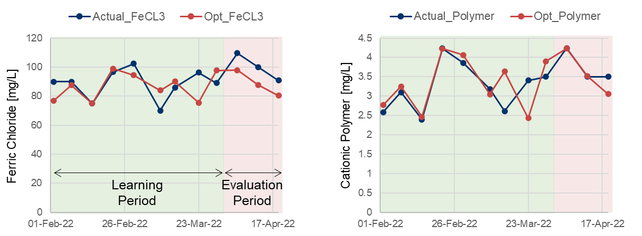

**(a) Ferric Chloride Dosage (b) Cationic Polymer Dosage**

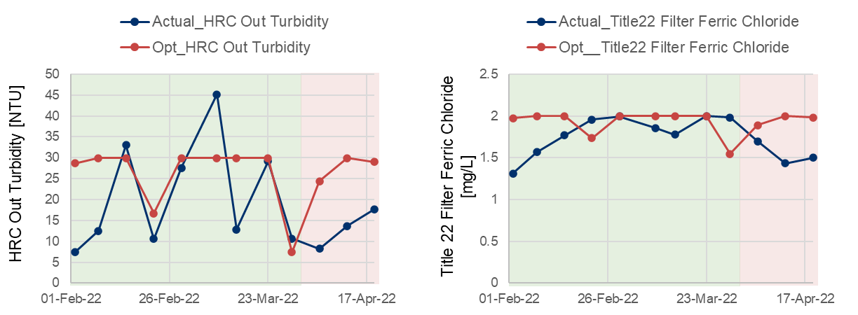

**(c) HRC Effluent Turbidity (d) Title 22 Filter Effluent Ferric Chloride**

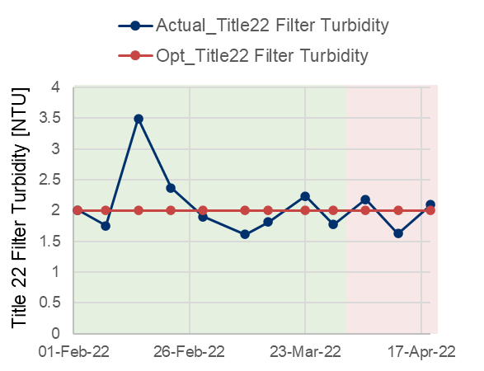

**(e) Title 22 Filter Effluent Turbidity**

Figure 1‑13 Optimization Results

* Relationships between Actual and Optimum Values

We compared actual values with optimum values as a summary of the optimization calculation. Figure 1‑12 (a) to (e) shows the comparison between actual and optimum values during the evaluation period by bar graphs. The blue bars are the sum or the average of actual values, and the red bars are the sum or the average of optimum values.

As shown in (a) and (b), ferric chloride dosage and cationic polymer dosages were reduced by 7% and 0.2%, respectively, because of the optimization calculation. The Title 22 filter effluent turbidity raised by 4% can be attributed by reduction of the total amount of chemical dosage.

However, the model accuracy was low as given article 3.4.3.2 Model Accuracy, the reliability of the model decreased compared to the hourly average model.

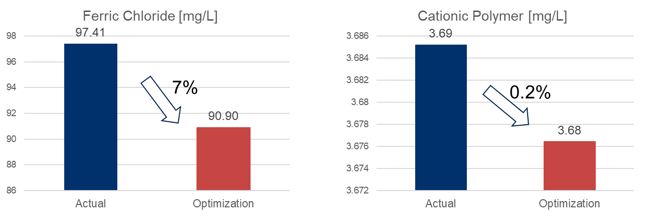

**(a) Ferric Chloride Dosage (b) Cationic Polymer Dosage**

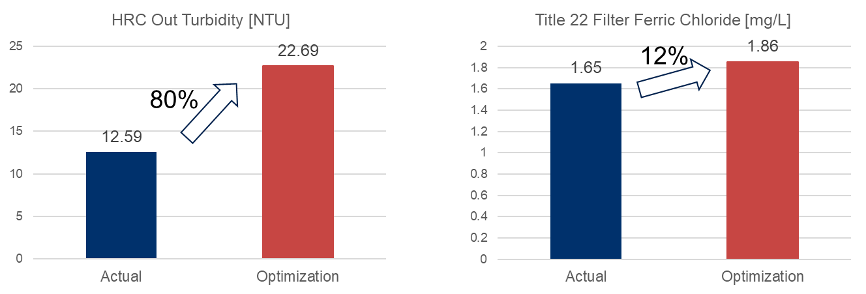

**(c) HRC Out Turbidity [NTU] (d) Title 22 Filter Effluent Ferric Chloride [mg/L]**

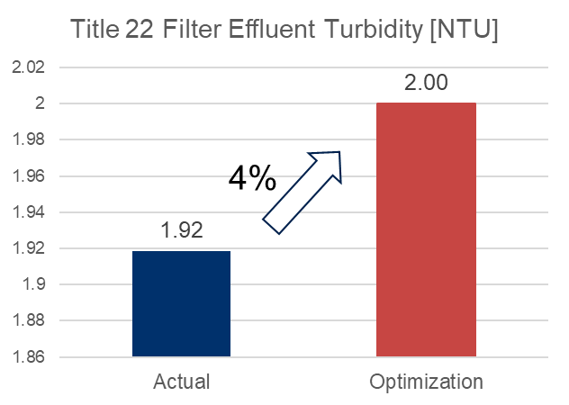

**(e) Title 22 Filter Effluent Turbidity [NTU]**

Figure 1‑14 Comparison between Actual Value and Optimum Value

* 1. **Recommendation**

Ferric chloride and cationic polymer should be injected in accordance with the change of water qualities such as influent water and turbidity for stable operation. However, the feed and effluent turbidity of HRT were measured by only grabbing. In Figure 1‑15, we highly recommend installing online turbidity meter and measure in real time at the feed and effluent of HRT that makes it possible to reduce those chemicals based on the fluctuation.

From the point of data analysis, we recommend installing an instrument at the Title 22 filter feed to measure ferric chloride concentration as shown in Figure 1‑15. With this, residual ferric concentration will be able to be predicted with better model accuracy.

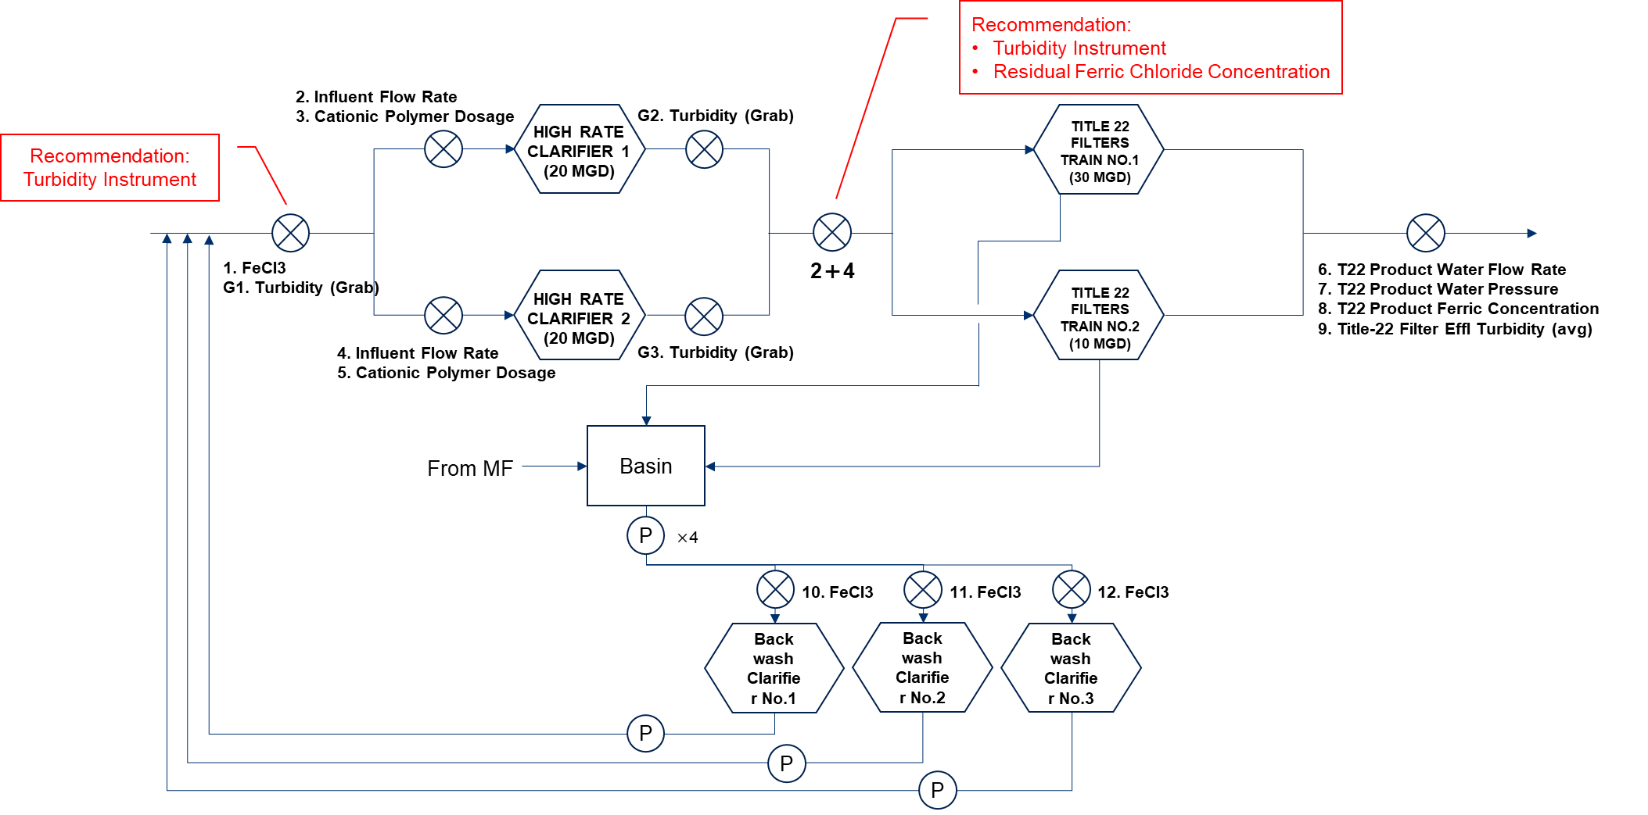

Figure 1‑15 Recommendation to Install Instruments

**Additional Materials**

## A1) RO System Configuration (OCWD, LVMWD)

The data set provided to this team is for the 100 mgd system. We note that the capacity has recently been upgraded to 130 mgd. The full-scale RO membrane system in OCWD, for the longer running 100 mgd of capacity, consists of 21 RO units (3 RO units x 7 RO trains) and each unit has 5 MGD capacity. As OCWD reported in Figure A.1**[14]**, these 21 RO systems are being operated by different types of RO membranes. Current analysis focuses upon RO UNIT B01. As shown in the figure below, the membrane type of RO UNIT B01 is Filmtec BW30XFRLE installed in October 2020.

RO UNIT B01 is a 3-stage configuration, with flow rate, pressure, conductivity, and differential pressure measured as shown in the Figure A.2. 50 categories of data were provided including feed & permeate flow rate, feed & permeate water qualities (such as conductivity, TOC, turbidity), feed & permeate pressure, Xact, and chemical dosage. Tag name list in OCWD is shown in Table A.1.

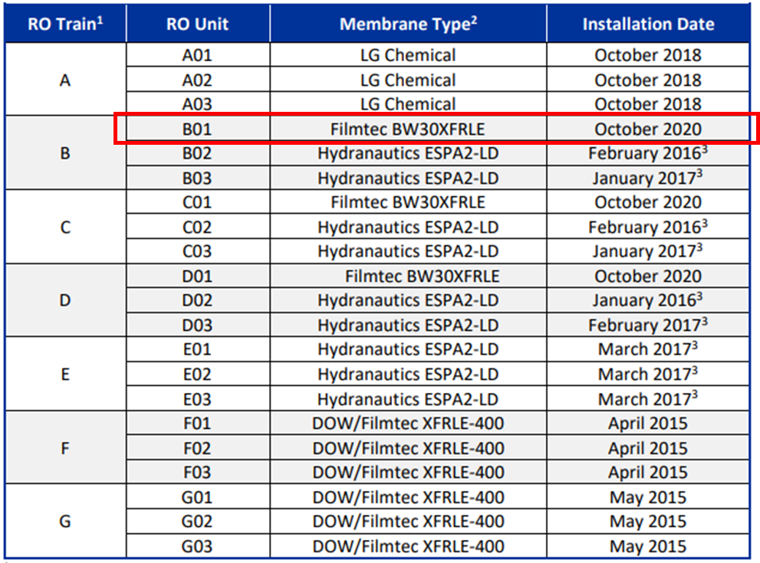

**Figure A.1: RO System Membranes (OCWD)**



**(a): The Whole RO System**



**(b): RO Unit B01 System**

**Figure A.2: RO System Configuration (OCWD)**

**Table A.1: Tag Name List (OCWD)**

|  |  |
| --- | --- |
| Tag Name | Variable Name |
| RO_B01 FW Press | RO B01 Feed Pressure |
| RO_Feed Cond | RO Feed EC |
| RO_01_FirstStageFeedFlow | RO Feed Flow Rate |
| RO_Feed Temperature | RO Feed Temperature |
| RO_Feed Ph | RO Feed pH |
| Sulfric Acid Usage | Sulfuric Acid Usage |
| Threshold Inhibitor Usage | Threshold Inhibitor Usage |
| RO_B01 FW B2 Press | RO B01 Feed Pressure |
| RO_01_SecondStageFeedConductivity | RO B01 Stage 2 Feed EC |
| RO_01_SecondStageFeedFlow | RO B01 Stage 2 Feed Flow Rate |
| RO_01_ThirdStageFeedConductivity | RO B01 Stage 3 Feed EC |
| RO_01_ThirdStageFeedFlow | RO B01 Stage 3 Feed Flow Rate |
| RO_01_ThirdStagePermFlow | RO B01 Stage 3 Permeate Flow Rate |
| RO_Feed TOC | RO Feed TOC |
| RO_B01 Blank 1 Perm Cond | RO B01 Stage 1 Permeate EC |
| RO_B01 Blank 2 Perm Cond | RO B01 Stage 2 Permeate EC |
| RO_B01 Blank 3 Perm Cond | RO B01 Stage 3 Permeate EC |
| RO_B01 Perm Cond | RO Combined Permeate EC |
| RO_Permeat TOC | RO Combined Permeate TOC |

* RO System Configuration of LVMWD

The RO membrane system in LVMWD is a pilot scale system. The RO system consists of 3-stage configuration, utilized the Toray TMG10D membrane, and is shown in the Figure A.3. Tag name list in LVMWD is shown in Table A.2.



**Figure A.3: RO System Configuration and Measurement Points (LVMWD)**

**Table A.2: Tag Name List (LVMWD)**

|  |  |
| --- | --- |
| Tag Name | Variable Name |
| PT_41095 | RO Stage 1 Feed Pressure |
| AIT_40006 | RO Feed EC |
| RO_01_FirstStageFeedFlow | RO Feed Flow |
| TIT_40005 | RO Feed Temperature |
| AIT_40008 | RO Feed pH |
| AI_31094 | UF Filtrate Total Chlorine |
| RO_01_SecondStageFeedConductivity | RO Stage 2 Feed EC |
| RO_01_SecondStageFeedFlow | RO Stage 2 Feed Flow |
| PT_41347 | RO Stage 3 Feed Pressure |
| RO_01_ThirdStageFeedConductivity | RO Stage 3 Feed EC |
| RO_01_ThirdStageFeedFlow | RO Stage 3 Feed Flow |
| AIT_40010 | RO Feed TOC |
| AIT_41092 | RO Stage 1 Permeate EC |
| AIT_41292 | RO Stage 2 Permeate EC |
| AIT_41392 | RO Stage 3 Permeate EC |
| AIT_41892 | RO Combined Permeate EC |
| AIT_41810 | RO Combined Permeate TOC |

## A2) Mathematical Optimization Problem

A formulated RO optimization problem for OCWD and LVMWD is given as follows and the optimization variable list is given as Table 1.1.1 and Table 2.1.1.

Mathematical optimization problem is formulated as minimizing $f(x)$ such that constraints $g_{κ}\left(x\right)≤0$ ($κ=1,2,…,K$), where $x∈R^{N}$ denotes the optimization variable, $f:R^{N}→R$ denotes the objective function (cost function), $g_{κ}:R^{N}→R$ denote $K$ constraint functions, $R$ denotes the set of real numbers, $N$ denotes the number of total variables, respectively.

* Optimization Problem (OCWD)

The objective function $f$ is sum of the threshold inhibitor usage formulated as follows:

$$\begin{aligned}f(x) =\sum_{t=1}^{L}{(c_{1}x_{ID0000}\left[t\right]+c_{2}x_{ID0001}\left[t\right])}\#\left(A2.1\right)\end{aligned}$$

Here, $x_{ID0000}\left[t\right]$ denotes sulfuric acid usage at time $t$, $x_{ID0001}\left[t\right]$ denotes the threshold inhibitor usage at time $t$, $c_{1}=248,c_{2}=2620$ denotes unit cost [US$/ton], and $L$ denotes the length (step size) of optimization period, respectively.

Constraint conditions are upper and lower limits, fluctuation range limits, water quality standards limit based on LRV. Intermediate variables $x_{ID1000}\left[t\right]$ (Stage1 permeate EC), $x_{ID2001}\left[t\right]$ (Stage2 permeate EC), $x_{ID3001}\left[t\right]$ (Stage3 permeate EC), $x_{ID4000}\left[t\right]$ (combined permeate conductivity), and $x_{ID4001}\left[t\right]$ (combined permeate TOC) are calculated by water quality prediction model. Here, a detail of each prediction model is provided in main section.

* Optimization Problem (LVMWD)

The objective function $f(x)$ is formulated as follows:

$$\begin{aligned}f(x) =\sum_{t=1}^{L}{(c_{1}x_{ID0000}\left[t\right])}\#\left(A2.2\right)\end{aligned}$$

Here, $x_{ID0000}\left[t\right]$ denotes UF filtrate total chlorine at time $t$, $c_{1}=100$ denote unit cost [US$/(mg/L)] coefficients, and $L$ denotes the length (step size) of optimization period, respectively.

Constraint conditions are upper and lower limits, fluctuation range limits, water quality standards limit based on LRV. Intermediate variables $x_{ID1000}\left[t\right]$ (Stage1 permeate EC), $x_{ID2001}\left[t\right]$ (Stage2 permeate EC), $x_{ID3001}\left[t\right]$ (Stage3 permeate EC), $x_{ID4000}\left[t\right]$ (combined permeate EC), and $x_{ID4001}\left[t\right]$ (combined permeate TOC) are calculated by water quality prediction model. Here, a detail of each prediction model is provided in main section.

## A3) Preprocessing Details

We have established a uniform outlier removal procedure which consists of two steps.

Step 1 performs data cleaning with 3 rules.

* Detect the periods where the feed flow rate is below a predefined level.
* Detect the periods where each measured value does not change for a predefined time.
* Detect the moments where the change rate of each variable in one step exceeds a predefined level.

The results are merged, and margins of a predefined timesteps before and after the detected periods are also treated as outliers.

In step 2, outliers are removed using filtering techniques that are common in the field of data analysis, for example, removing values outside of the mean ±3σ of the data and applying a Kalman filter.

The preprocessing parameters for OCWD and LVMWD are summarized in Table A3.1, which lists the threshold values for each condition in step 1. For the LVMWD data, filtering methods in step 2 are also applied. Table A3.2 summarizes the variables to which step 2 was applied and the method used.

**Table A3.2: Variable Names and Methods Adapted from Step 2 (LVMWD)**

|  |  |
| --- | --- |
| Step 2 | Variable Names（LVMWD） |
| Delete time above the mean ±3σ | Feed TOC  Permeate TOC |
| Kalman filter | 3rd Stage Feed Flow Rate  RO Feed Temp  RO Feed pH |

**Table A3.1: Thresholds for Each Operating Condition in Step 1 (OCWD, LVMWD)**

|  |  |  |  |
| --- | --- | --- | --- |
|  | Items | OCWD | LVMWD |
| Step 1 | (1) Feed Flow Rate | $≤$ 3000 [gpm] | $≤$ 10 [gpm] |
| (2) Constant Value Continuation Steps | $≥$ 5 [steps*] | $≥$ 10 [steps*] |
| (3) Changing Rate | $≥$ 20% | $≥$ 20% |
| (4) Margin | 2 [steps*] | 5 [steps*] |

*OCWD’s 1-step is 30-minute and LVMWD’s 1-step is 1-minute in the condition of (2) and (4).

## A4) Mathematical Equations

* Prediction Evaluation Index

The prediction evaluation indexes are Mean Absolute Percentage Error (MAPE) $E_{MAPE}$ [%] and Root Mean Percentage Error (RMSE) $E_{RMSE}$. MAPE indicates a relative prediction error and RMSE is an absolute prediction error. They are formulated as follows: $$\begin{aligned}E_{MAPE}=\frac{100}{L}\sum_{t=1}^{L}{\frac{\left|y_{Pre}\left[t\right]-y_{Act}\left[t\right]\right|}{y_{Act}\left[t\right]}} [\%]\#\left(A4.1\right)\end{aligned} \\ \begin{aligned}E_{RMSE}=\sqrt{\frac{1}{L}\sum_{t=1}^{L}{{\left(y_{Pre}\left[t\right]-y_{Act}\left[t\right]\right)}^{2}}}\#\left(A4.2\right)\end{aligned}$$ 
Here, $y_{Act}\left[t\right]$ is the actual data and $y_{Pre}\left[t\right]$ is the predicted data at time $t$. $L$ is the length of the prediction period.

* Calculated Variable (OCWD, LVMWD)

The calculated 1st stage feed flow rate $Q_{1, feed}$, 2nd stage feed flow rate $Q_{2, feed}$, and 3rd stage feed flow rate $Q_{3, feed}$ are given, respectively, as follows:

$$\begin{aligned}Q_{1, feed }=Q_{1, perm}+Q_{2, perm}+Q_{3, perm}+Q_{3, conc}\#\left(A4.3\right)\end{aligned}$$

$$\begin{aligned}Q_{2, feed }=Q_{1, feed }-Q_{1,perm}\#\left(A4.4\right)\end{aligned}$$

$$\begin{aligned}Q_{3, feed }=Q_{2, feed }-Q_{2, perm }\#\left(A4.5\right)\end{aligned}$$

Here, $Q_{i, perm} and Q_{i, conc}$ denote permeate and concentrate flow rates at stages $i=1,2,3$.

The 2nd stage feed EC ${EC}_{2, feed}$ and 3rd stage feed EC ${EC}_{3, feed}$ are calculated based on the law of conservation of mass using the following equations:

$$\begin{aligned}{EC}_{2, feed}=\frac{Q_{1, feed}×{EC}_{1, feed}+Q_{1, perm}×{EC}_{1, perm}}{Q_{1, feed}-Q_{1, perm}}\#\left(A4.6\right)\end{aligned}$$

$$\begin{aligned}{EC}_{3, feed }=\frac{Q_{2, feed}×{EC}_{2, feed}+Q_{2, perm}×{EC}_{2, perm}}{Q_{2, feed}-Q_{2, perm}}\#\left(A4.7\right)\end{aligned}$$

In the optimization phase, we need to predict permeate ECs (${EC}_{1, perm} and{EC}_{2, perm}$) by the prediction models, which use feed ECs as explanatory variables. Unmeasured feed ECs (${EC}_{2, feed} and{EC}_{3, feed}$) are calculated by Equations ($A4.5$) and ($A4.6$).

* Multiple Linear Regression Model

Let $X={\left(x^{1},x^{2},…,x^{N}\right)}^{T}$ be the design matrix, $x^{i}={\left(x_{1}^{i},x_{2}^{i},…,x_{M}^{i}\right)}^{T}$ be the $i$-th explanatory vector, $y={\left(y^{1},y^{2},…,y^{N}\right)}^{T}$ be the predictive vector, and $(x^{i},y^{i})$ be the $i$-th training dataset.

In Multiple Linear Regression (MLR), the estimated parameters $\hat{w}={\left(\hat{w_{1}}, \hat{w_{2}},…,\hat{w_{M}}\right)}^{T}$ and $\hat{w_{0}}$ are shown as follows:

$$\begin{aligned}\hat{w}={\left(X^{T}X\right)}^{-1}X^{T}y\#\left(A4.8\right)\end{aligned}$$

$$\begin{aligned}\hat{w_{0}}=\overline{y}-(\hat{w_{1}}\overline{x_{1}}+\hat{w_{2}}\overline{x_{2}}+…+\hat{w_{M}}\overline{x_{M}})\#\left(A4.9\right)\end{aligned}$$

1. G. Welch and G. Bishop: “An Introduction to the Kalman Filter”, Univ. of North Carolina (1995)  
   https://perso.crans.org/club-krobot/doc/kalman.pdf
2. Breiman, L. (2001) Random Forests. *Machine Learning*, **45**, 5-32.
3. Yasuhiro Matsui et al.: “Evaluation of nanofiltration process for fluoride removal from ground water in the Chiang Mai Basin.”, Doboku Gakkai Ronbunshuu G 62(4):403-414 (2006)
4. https://www.ocwd.com/wp-content/uploads/2020-gwrs-annual-report-appendices-1.pdf
5. <https://wwwbrr.cr.usgs.gov/projects/GWC_chemtherm/software.htm>
6. David Hasson, Andrei Cornel: “Effect of residence time on the degree of CaCO3 precipitation in the presence of anti-scalant”, Desalination Volume 401 (2017)
7. R. Tanabe and A. Fukunaga: “Success-History Based Parameter Adaptation for Differential Evolution,” Proceedings of IEEE Congress on Evolutionary Computation 2013, pp.71–78 (2013)
8. K. Deb: “An Efficient Constraint Handling Method for Genetic Algorithms”, Computer Methods in Applied Mechanics and Engineering, Vol. 186 No. 2-4, pp.311-338 (2000)
9. The Black-box Optimization Benchmarking (BBOB) workshop (https://numbbo.github.io/workshops/)
10. Recycled Water Master Plan West Basin Municipal Water District ([West-Basin-Master-Plan_final_rev4.pdf (westbasin.org)](https://www.westbasin.org/wp-content/uploads/2022/05/West-Basin-Master-Plan_final_rev4.pdf))
11. Wastewater Treatment Plant Master Plan, APPENDIX D: TITLE 22 REQUIREMENTS (https://www.napasan.com/DocumentCenter/View/276/Appendix-D-Title-22-Requirements-PDF)
12. Yokogawa Technical Report English Edition, Vol.59 No.1 (2016) (https://www.yokogawa.com/about/research-development/rd_te_report/yokogawa-technical-report2010-2019/rd_te_report_a05901/#Vol-59-No-1-2016)
13. Principal component analysis (https://en.wikipedia.org/wiki/Principal_component_analysis)
14. GWRS 2020 ANNUAL REPORT (https://www.ocwd.com/wp-content/uploads/2020-gwrs-annual-report-appendices-1.pdf)